United Bank of Philadelphia - Android Application - System Proposal Document

Ivan Novasak

Southern New Hampshire University

IT 510: Advanced Information Technology

Raymond J. Curts, PhD

2024 February 11

# United Bank of Philadelphia - Android Application - System Proposal Document

This document serves as the proposal for a new Android application (app) for customers of United Bank of Philadelphia. This document covers an overview of who United Bank of Philadelphia are, what their current online system is, a business case for making this Android app, the app’s design, requirements, timeline, planning phases, and system architecture.

**Introduction and Business Case Proposal**

This business case proposal concerns a chain of banks in Pennsylvania: United Bank of Philadelphia. As of 2022, they still do not have an SMS (text message) or smartphone app-based transaction alert system for users to know of their account activity while on-the-go. So, this proposal is for a team to make an Android app for the bank and their customers, filling this need.

# Background and History

## *Who is United Bank of Philadelphia?*

According to Ayana Jones in a *Philadelphia Tribune* article entitled “United Bank marks 25th anniversary”, United Bank of Philadelphia is Philadelphia's only African-American-owned bank and was founded in 1992 by Emma C. Chappell (Jones, 2017). The article states that in the beginning United Bank of Philadelphia was offering loans to the faith-based community, which is an area that other banks considered risky to loan money to (Jones, 2017). Later on after the 2008 financial crash, they shifted to the small business community for portfolio balancing (Jones, 2017). The article later states that Dimitria Davenport, vice president of Community Banking and Compliance at United Bank of Philadelphia, said the #bankblack movement on social media caused their marketing team to try to reach out to younger customers (Jones, 2017).

## *Background: United Bank of Philadelphia's Online Presence*

United Bank of Philadelphia has a website located at <https://ubphila.com/> which provides the ability for customers to “view current account balances or check to see if transactions have cleared”, transfer funds between checking and savings accounts, defined recurring internal transfers, build a rolling history with up to 18 months’ transactional history, bill payment, and download PDFs of statements up to 12 months in the past (United Bank of Philadelphia, 2023).

**Problem Statement**

***Lack of a Smartphone Application or Transactions Alert System***

The website works on current Android phones and tablets as per testing on a current smartphone, but it was not designed for such devices and text can appear small, requiring the user to zoom and scroll both horizontally and vertically to read it. The website has no way to push information to users when activity happens; users must manually log into it every time they need to check their account balances and activity. Also, the website uses only a simple username/password format for logging in, with an accompanying security question that is user-set and may pop up when logging in from a new computer or geographic location. No multi-factor authentication facility is present.

***Impacts on Convenience and Security for Customers and the Bank***

According to René Bennett, of Bankrate, their article entitled *7 key benefits of mobile banking* highlights a Chase study indicating “87% of US adults use a mobile banking app at least once a month” (Bennett, 2023). The article states that apps can warn the customer if they are overspending, allow customers to send money to friends easily, and access customer service quickly by tapping a button (Bennett, 2023). Other benefits include having a clear view of who is accessing the customer's finances, and higher account security via multi-factor authentication (Bennett, 2023).

One type of multi-factor authentication is where the customer logs in via username/password but then gets sent a single-use code to their phone by SMS that they must enter to successfully log in (Bennett, 2023). Other systems allow the user to use biometric information like a fingerprint or face scan on their phone as that second layer of identification (Bennett, 2023). Another very handy feature some banking apps offer is the ability to disable the debit card from being used right from the app (Bennett, 2023). Francois Amigorena, of CPO Magazine, says in an article entitled “MFA and the Consequences for Companies Who Don't Use It”, that companies who don't use multi-factor authentication are at risk of becoming victim to phishing attacks and since the credentials being used to log in are legitimate, it may be difficult to know if a security violation has happened (Amigorena, 2019). The article then states that as of the mid-2010s, multi-factor authentication was being used by only 38% of companies (Amigorena, 2019). The main statement Amigorena wants companies to know is, “Any company, regardless of size should be using MFA as part of their security strategy as it can be one of the easiest ways to secure accounts” (Amigorena, 2019).

Finally, there is the high uptake of banking apps of the younger generations. According to Alexandria White, of CNBC, Millennials and Generation Z (collectively born from approximately the 1980s through the 2010s decades) have 98% to 99% banking app uptake which was found in a Chase study called the *Digital Banking Attitudes Study* (White, 2023). United Bank of Philadelphia may be missing these younger customers they were hoping to get when they joined the #bankblack social media movement and so by having a mobile app, stakeholders and customers can be assured that United Bank of Philadelphia is keeping up with contemporary banking practices around the industry.

**Audiences and Communication Plan**

***What audiences are relevant for the proposed solution?***

The relevant audiences for the development of the Android banking app are the bank's upper management, IT staff and contractors, customer services team, and customers. According to the article entitled *Online Technical Writing: Audience analysis: Just who are these guys?* by David McMurray, the audiences reflect the types listed in Table A-1 (McMurray, n.d.):

**Table A-1**

*Audience Types. Adapted from (McMurray, n.d.).*

|  |  |
| --- | --- |
| **Audience** | **Audience Type** |
| Upper Management | Executives |
| IT Staff & Contractors | Experts & Technicians |
| Customer Services Team | Technicians & Nonspecialists |
| Customers | Nonspecialists |

***What should each audience know about the proposed solution?***

Upper Management consists of people like CEO Evelyn Smalls, Dimitria Davenport, and the rest of the people on the Board of Directors who are in charge of major decisions at the bank, including authorization of funds for new product developments. They may have some IT background but it's not their specialty and so the IT staff and contractors who are more likely to be engineers will need to explain to upper management how development of this new app will benefit both the investors and customers and is essential to United Bank of Philadelphia's future (McMurray, n.d.). Upper management staff, like Evelyn Smalls and Dimitria Davenport, will need to work closely with IT staff on choosing which product to develop, how much it will cost, how long it will take to make, and developing a marketing message for customers.

The IT staff as well as contractors will be in charge of making the new Android app. As IT engineers and other similar technology experts who are not financial decision makers at United Bank, they don't need to know about the cost of the product to develop nor how to market it to customers (McMurray, n.d.). They do, however, will need to determine how many people to hire for developing it and developing a timescale with the components and involved contractors. The needs of the bank are an app that can both display and relay the same account data customers log in to see as well as introduce a new multi-factor authentication system that can be used in the new app and replace the existing username/password/secret recovery question login system. IT staff will also be in charge of creating an easy-to-read frequently asked questions document for the Customer Services team, so the IT staff need both software engineers as well as at least 1 technical writer who has experience bridging communication between engineers and non-technical customers (McMurray, n.d.). United Bank will need to hire more people to be part of the Customer Services team when the new app is being released because customers are likely to have a lot of questions about whether their funds are safe, how to access their account from the new app, whether their existing login information is still relevant, how to download and install the app, etc.

The customers are the next audience of concern. Their needs extend so far as to staff at United Bank assuring them that their information and funds are safe and will be even more secure after the new app launches as the extra identification component the app will use will keep hackers without access to your phone unable to access your account. They do not, however, need to know about anything involving software engineering or the project's budget (McMurray, n.d.). Also essential is social media marketing in relevant financial and minority business circles once the app is launched, allowing more people to be aware of United Bank of Philadelphia and that even small local banks can have apps with the same popular security and convenience features big-name globally known banks have.

***Communications Plan***

It is expected the project will take close to a year, so preparing for a late November/early December holiday season 2024 release may be logical. During the first months of 2024 staff can host meetings between the Board of Directors and senior IT engineers to determine the most important features this new app needs to have. Development will take place starting in the Spring, with testing and debugging in Summer into the Autumn and a final rollout in time for the December holiday shopping period. Customers will be informed by email and physical mail in November and December 2024 about the new app and how they can download it, with a hotline phone number on the flier.

**Project Plan**

The next section of this document is for identifying the Work Breakdown Structure (WBS), Project Control Plan, Timeline, and Project Monitoring for the creation of an Android application (app) for United Bank of Philadelphia. Also, to be identified are the features the app is to have, what job positions to hire for, the budget for this project, and phases of the project, all of which are, according to Christine Organ and Cassie Bottorff of Forbes Advisor, elements of the WBS (Organ & Bottorff, 2023). The Timeline section will show a Gantt chart that lays out the project's major phases as a whole and what months and dates they take place in, which, according to Scott Tilley and Harry J. Rosenblatt in *Systems Analysis and Design*, is useful for showing the general timeline of a project (Tilley & Rosenblatt, 2016, pp 72/73).

# Work Breakdown Structure

## *Project Definition and Scope*

The project's end goal is a fully functional Android app that allows users to get online access to their United Bank of Philadelphia account via smartphone or tablet.

## *Project Phases and App Features*

According to Jane Bondar, the Mobile Developer Lead at NIX United, the phases of app development are as follows (Bondar, 2023):

1. Strategy;
2. Design;
3. Development;
4. Testing;
5. Release and ongoing support (Bondar, 2023).

The first phase, strategy, is where the app's purpose is defined, the target audience is established, existing information technology (IT)/web development staff researches apps from other banks, and the platform is selected (Bondar, 2023). The features this Android banking app will have are features recommended by Community Bank, N.A.'s *Mobile Banking: 10 Must-Have Features and Benefits* article are (Community Bank, 2022):

1. 2-Factor/Biometric Authentication;
2. A customizable user interface;
3. Banking functions such as “ability to deposit checks, pay bills, make loan payments and transfer money between accounts” (Community Bank, 2022);
4. Transaction alerts;
5. Financial management tools (to budget and track trends);
6. Digital wallet;
7. Ability to lock/freeze the debit card in case if it's misplaced;
8. Set travel notices;
9. Quick access to bank representatives (via phone number or online chat) (Community Bank, 2022).

Next comes the design phase, which starts with hiring a team consisting of (Bondar, 2023):

1. Product owner;
2. Project manager;
3. Business analyst;
4. 3 app developers;
5. Back-end developer;
6. User interface (UI) / user experience (UX) designer;
7. 2 quality assurance (QA) engineers (Bondar, 2023).

In the case of United Bank of Philadelphia, the staff will need to be hired, as according to (Novasak, 2023), there is no existing Android app that has existing staff working on it (Novasak, 2023). So, this phase of the project will have an additional step before design can take place: advertising job offers on job websites, interviewing prospective employees, and training them once hired. According to Raj Sanghvi, of Bitcot, Inc. in an article entitled *Android App Development Cost: Factors, Estimates, and Budgeting*, the average hourly rates for Android app developers range from $50 to $250 per hour, with developers in North America and Western Europe being at the higher end of that range (Sanghvi, 2023). The next steps in the design phase involve clarifying the requirements of what kind of UI will be made, laying out the look and feel of the interface including colors and buttons, and maintenance/testing (Bondar, 2023). The design team will continue to be involved in the project through the next phase: development (Bondar, 2023).

Development will be via the Agile method, where each feature is worked on solely, intensively for 2 weeks, then the leader of the development team can review the functionality and test the specific function (Bondar, 2023). Since this will be an Android app, the Java and Kotlin programming languages are the ones being used for making this app (Bondar, 2023). An app architecture has to be chosen, which may be any of Model View Presenter (MVP), Model View Viewmodel (MVVM), Viper, or Redux (Bondar, 2023). A backend such as Firebase, Amazon Web Services (AWS) Mobile Hub, CloudKit, will also need to be chosen (Bondar, 2023). Next comes frameworks and libraries selections - for Android Play Services and Google Pay are 2 of these (Bondar, 2023). Frameworks and libraries speed up the development process and are essential as they both are proven standardized methods for accomplishing certain mobile functionalities like location services, as well as not needing a long development process coding every feature by hand (Bondar, 2023). Next the development team needs to decide whether to use an existing application programming interface (API) or create a new one (Bondar, 2023). According to Novasak (2023), United Bank of Philadelphia has a website login/password/recovery question feature. Whether this can be utilized as an API or not will need to be discussed amongst the developers and United Bank's existing IT staff. Next are network models and database design (Bondar, 2023). Developers next communicate with the designers and the business analyst and make sure the limitations as well as the optimal solution of the mobile system are known before further development takes place (Bondar, 2023). Finally, the development team configured repositories like Github, and the app is now ready for testing, which is the next major phase.

Testing the new app is the next development phase and is crucial to ensure devices are compatible, it is secure, has high usability, and performs well under load (Bondar, 2023). The QA team are the employees who will be in charge of this testing (Bondar, 2023). These tests include load and stress testing for both the app itself as well as the backend, security/penetration testing, and usability testing (Bondar, 2023). As this is a banking app, security/penetration testing ought to be given highest priority to ensure hackers can't steal customers’ funds or private information (Bondar, 2023). Usability testing is also essential to ensure the customers find it easy and convenient to bank via this new app (Bondar, 2023). A soft launch of a beta version of the app targeted to existing online banking customers would be good to do to find any issues in the usability flow (Bondar, 2023).

The final stage is release and ongoing support (Bondar, 2023). At this stage the developers submit the completed app to Google Play for publishing after it has been approved by the project manager (Bondar, 2023). A suggestion by the author of this document is to have a hotline available for new users of the app who need help getting started. This will probably involve a second hiring phase around the time development of the app is being finalized.

Microsoft Project screenshots showing the timing of each of these phases are shown in Figures A-1 to A-4. The list of phases and their associated tasks, as well as their timing, predecessor task numbers, and resources needed is shown in the large lower left pane of each of those 4 screenshots.

**Figure A-1**

*Project WBS and timeline tasks from the strategy phase through the sixth task of the design phase.*

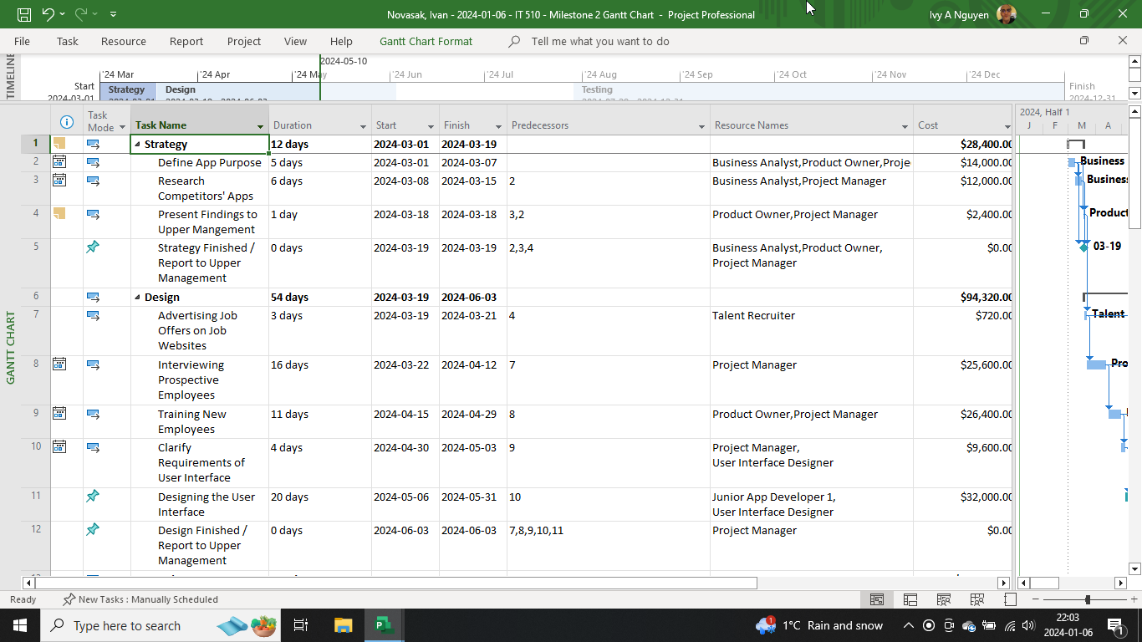

**Figure A-2**

*Project WBS and timeline tasks from the first 12 tasks of the development phase.*

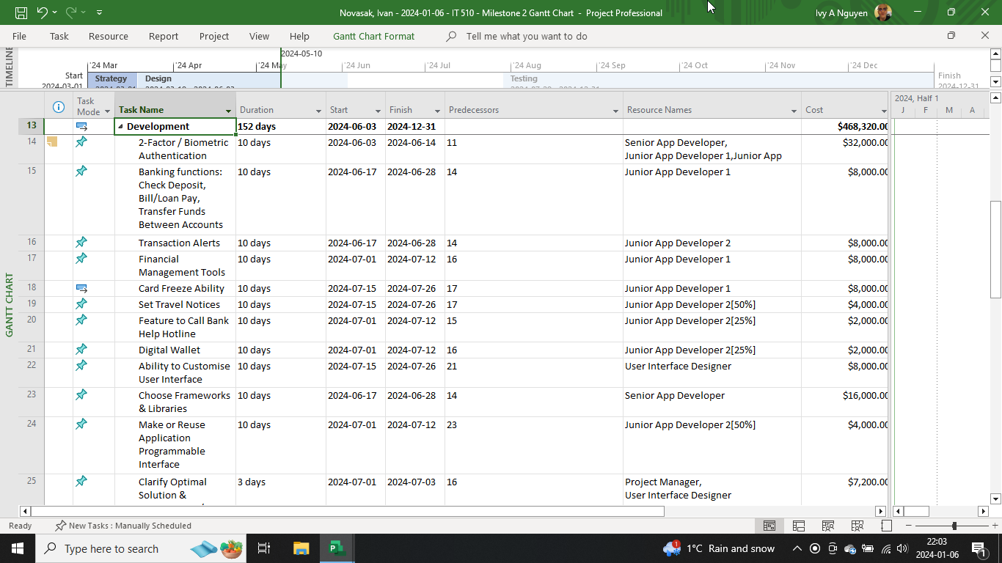

**Figure A-3**

*Project WBS and timeline tasks from the thirteenth task of the development phase to the eighth task of the testing phase.*

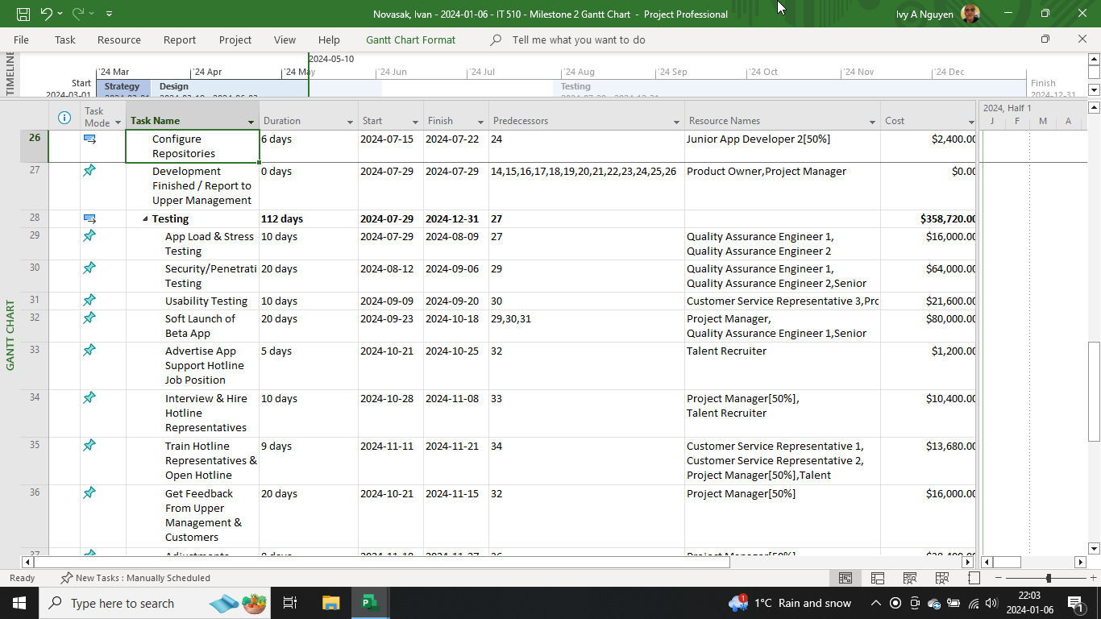

**Figure A-4**

*Project WBS and timeline tasks from the ninth task of the testing phase to the fourth task of the release & support phase (the end of the project).*

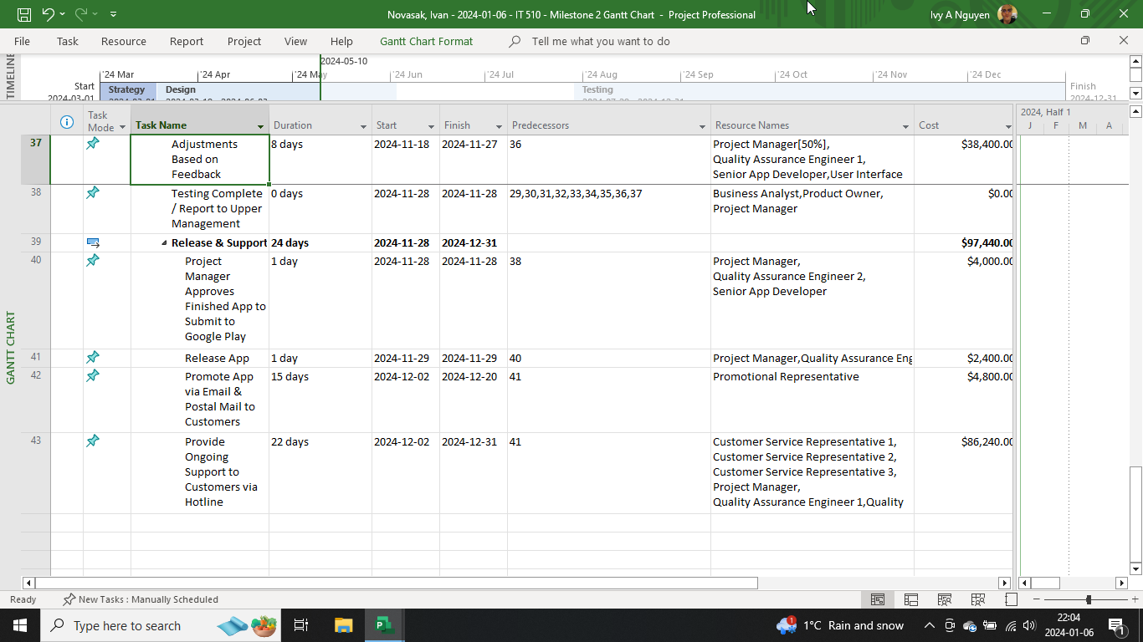

**Figure A-5**

*Gantt Chart showing timeline and employees for March through early July.*

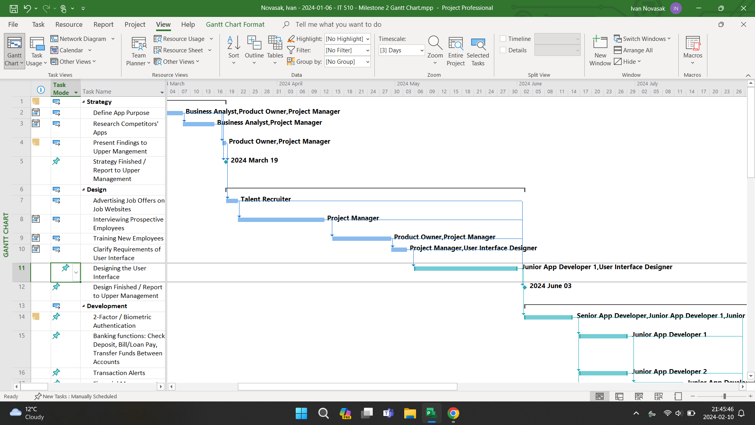

**Figure A-6**

*Gantt Chart showing timeline and employees for early July through late September.*

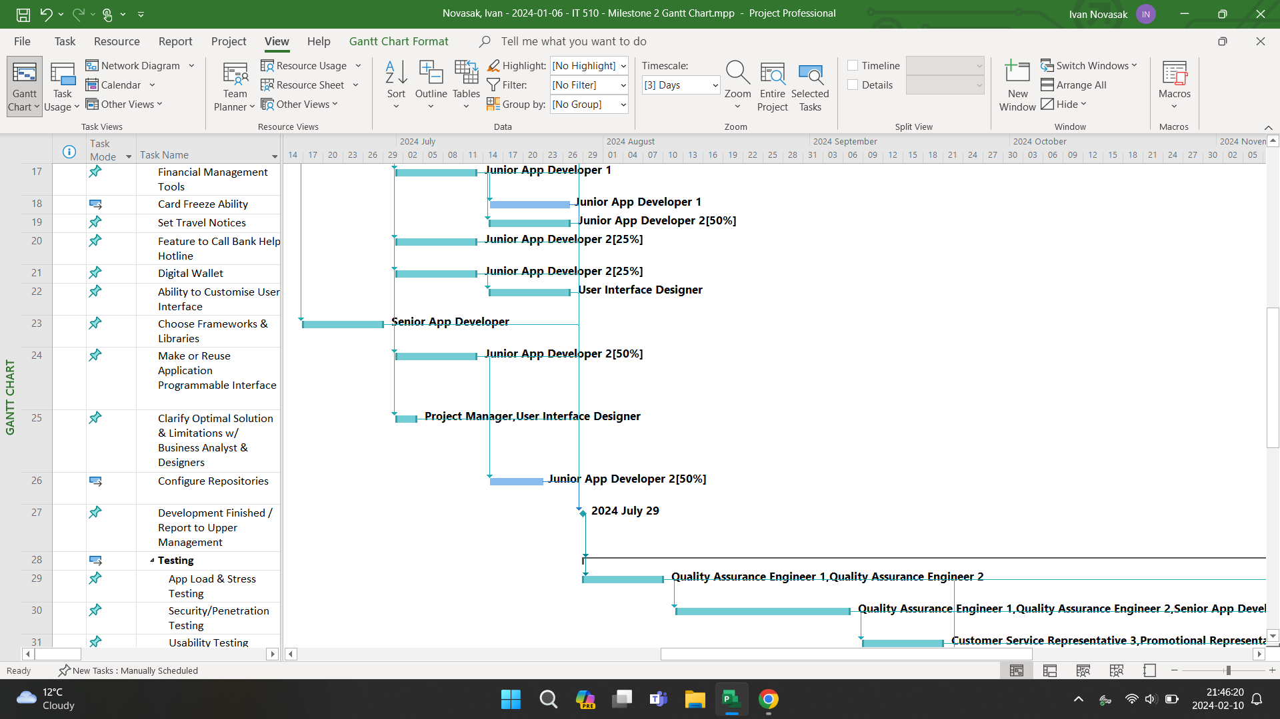

**Figure A-7**

*Gantt Chart showing timeline and employees for late September through December (project end).*

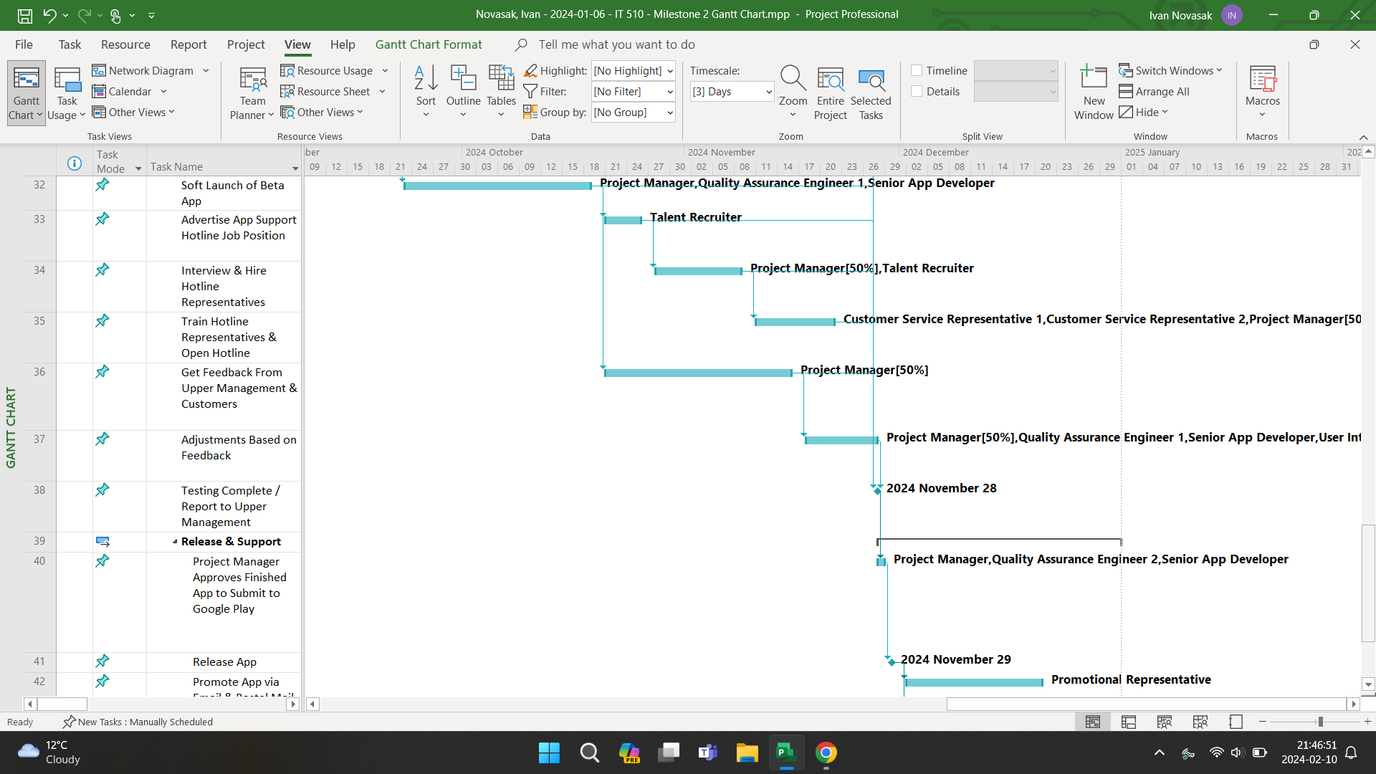

***Resources***

The full list of people to be hired and their pay rates for working on this Android app are shown in the Microsoft Project screenshot in Figure A-8.

**Figure A-8**

*Employees’ titles are in the Resource Name column and their pay rates are in the Std. Rate column.*

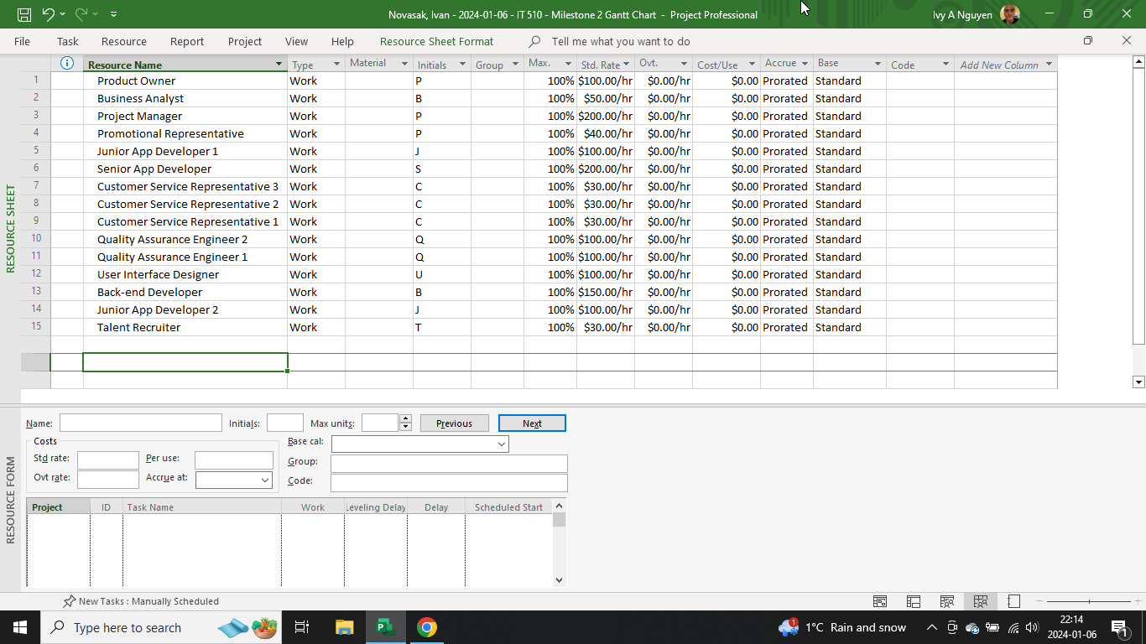

The hourly pay rates of the app developers, quality assurance engineers, user interface designer, and back-end developer are based on the rate stated by Raj Sanghvi in *Android App Development cost: factors, estimates, and budgeting* (Sanghvi, 2023). The rate of pay for the business analyst was chosen based on the annual salary of $81,745 displayed by Indeed for a business analyst in Philadelphia (Indeed, n.d.). The pay rate of the project manager was chosen based on the 90th percentile annual salary quoted by the All Business Schools *Project Manager Salary Guide* web page, which is $159,150 (All Business Schools, 2024). The product owner's hourly rate was based on the annual average salary of $157,458 stated by Salary.com's *Agile Product Owner Salary in Philadelphia, Pennsylvania* web page (Salary.com, n.d.). The pay rate of the customer service representatives is based on the average annual salary of $42,914 as stated by the Glassdoor article *How much does a Customer Service Representative make in Philadelphia, PA?* (Glassdoor, 2024). The talent recruiter's pay rate was based on the rate of $27.23 per hour as of 30 December 2023 that was stated by the ZipRecruiter web page *Talent Acquisition Recruiter Salary* (ZipRecruiter, n.d.). The promotional representative's pay rate was based on the average US annual salary of $61,380 for this position, stated by Comparably in the article *Promotional Representative Salary* (Comparably, n.d.).

***Costs***

The full costs of all phases of this project, including a per-task breakdown with the phases is shown in Figures A-9, A-10, and A-11, with amounts shown in the Total column in each of the 3 screenshots. The rows shown in **bold** indicate the cost for the phase as a whole.

**Figure A-9**

*Strategy and design phases, as well as the first 2 tasks in the development phase.*

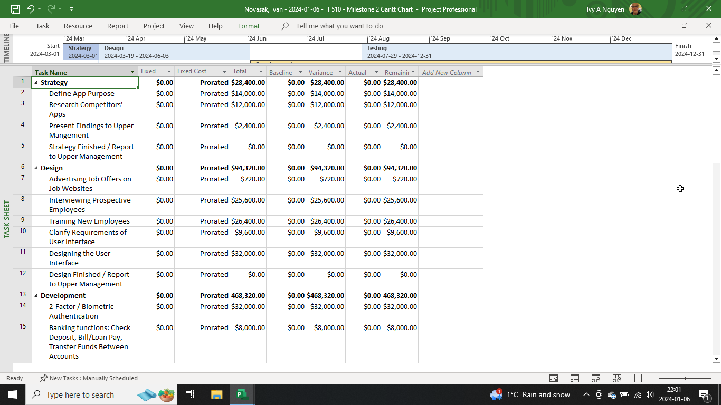

**Figure A-10**

*The third through fourteenth task in the development phase, as well as the first 4 tasks in the testing phase.*

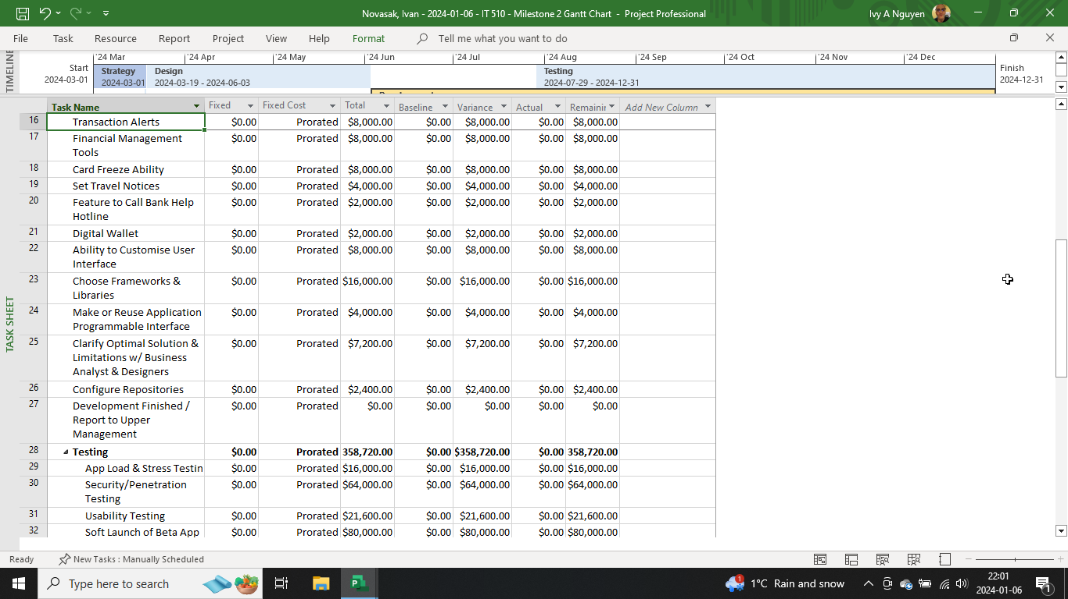

**Figure A-11**

*The fifth through tenth task in the testing phase as well as the entire release & support phase.*

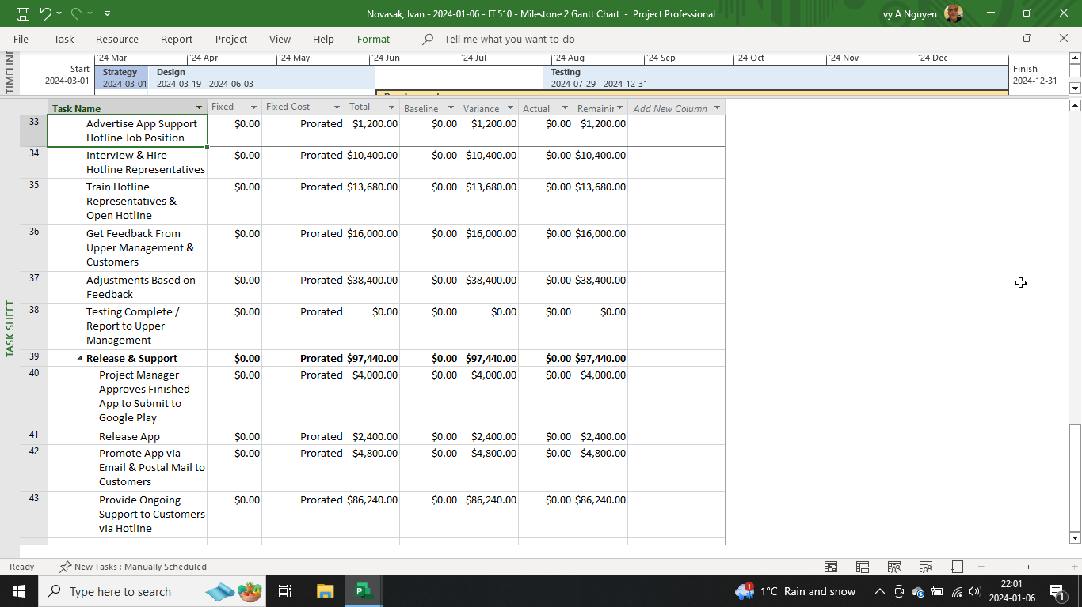

Summing the costs of the phases, $97,440 + $358,720 + $468,320 + $94,320 + $28,400 = a grand total of $1,047,200 for the entire project.

**Project Monitoring and Control Plan**

***Monitoring and Checklists***

One type of monitoring that will be done in this project is structured walk-throughs, which is where team members review each other's contributions to the project and mention anything they thought may have been overlooked (Tilley & Rosenblatt, 2016, p 83). To stay on the Agile schedule of 2 weeks per feature, it may be a good idea to have these reviews peppered into the development segments rather than have it all at the end of the feature development. Another tool for staying on track is to make a checklist with milestones for each item in the project - major and minor - that needs to be done over the course of the project (Tilley & Rosenblatt, 2016, p 84). Slack time - a buffer between different development phases - can be handy in case any phase or task within the project gets delayed (Tilley & Rosenblatt, 2016, p 84). Thirdly, regular meetings with both the project manager, team supervisors, and between senior and junior developers is important for understanding any problems that may affect the timeline for the project as well as any assistance that may be needed (Tilley & Rosenblatt, 2016, pp 84/85). The project manager must also have their own meetings with upper management and report on the app's development progress (Tilley & Rosenblatt, 2016, p 84). These meetings take place at the end of each milestone (shown in Figures A-1 to A-4). The critical path of the project is indicated in Figures A-1 to A-4 in the Predecessors column. Each row is a task, and so the critical path can be deduced by matching the row, which represents a task, with the Predecessor column.

***Audiences***

In Novasak (2023), the 4 audiences of concern were laid out and are as follows: upper management, IT staff/contractors (who will now also include the people being hired in the early phase in this project plan), the customer services representatives (who will also include the new hires to handle the app support hotline), and the customers (Novasak, 2023). Some of these audiences are involved in every phase of the project, while others are only involved in certain phases.

The project manager is involved in all 5 phases of this project, as can be noticed in Figures A-1 to A-4. The developers get hired during the design phase, but most of them are not yet working on the app until the development phase (their tasks are shown in Figures A-1 to A-3). The QA engineers and customer service representatives begin working during the testing phase (their tasks are shown in Figure A-3). The talent recruiter is part of the project only during the design and testing phases (their tasks are shown in Figures A-1 and A-3). The promotional representative is working only during the release & support phase (their task is shown in Figure A-4). The business analyst is part of the strategy phase as well as the final step in the testing phase, for the meeting with upper management once testing is finished and the app is about to be released (shown in Figures A-1 and A-4). Some of the customers begin to be able to use the new app during the beta launch in the testing phase (shown in Figure A-3) with all customers gaining the ability to use the app during the final launch at the end of the release & support phase (shown in Figure A-4).

***Critical Paths and PERT/CPM Charts***

According to Tilley & Rosenblatt (2016, p 81), the critical path in a project is the list of dependent tasks that would result in the project not being able to move onto the next step. The critical paths in this project can be deduced from the task ID, start date, finish date, and predecessor columns shown in Figures A-1 to A-4. Another way to show this is with Program Evaluation Review or Critical Path Method (PERT/CPM) charts, which, according to Tilley & Rosenblatt (2016, pp 73 & 82), show the critical paths visually with tasks represented by boxes that contain the task name, start date, finish date, ID, and duration. These boxes are connected by one-way arrows, with the red color being used for tasks along the critical path.

Figure A-12 is the PERT/CPM chart for the overall phases in this project.

**Figure A-12**

*Adapted from (Tilley & Rosenblatt, 2016, p 82).*

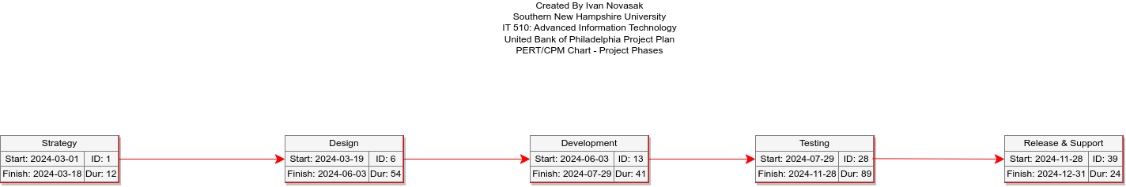

The critical path, audience involvement, as well as how the project will be monitored have been considered. The next component to be covered is the timeline.

**Timeline**

The general timeline for the project is as follows:

* 2024 March 1–2024 March 18: The project begins with the strategy phase;
* 2024 March 19–2024 June 3: The design phase is next;
* 2024 June 3–2024 July 29: The development phase is third;
* 2024 July 29–2024 November 28: The testing phase is fourth;
* 2024 November 28–2024 December 31: The final phase is the app release and ongoing support phase.

The timeline may have to be adjusted during the project or if anything was overlooked and discovered later. For now, it is decided to be a 10-month project commencing in March 2024. Figure A-13, shown below, is a Microsoft Project screenshot displaying this timeline in a graphical format.

**Figure A-13**

*The start dates, end dates, milestones, and project phases in chronological order from left to right.*

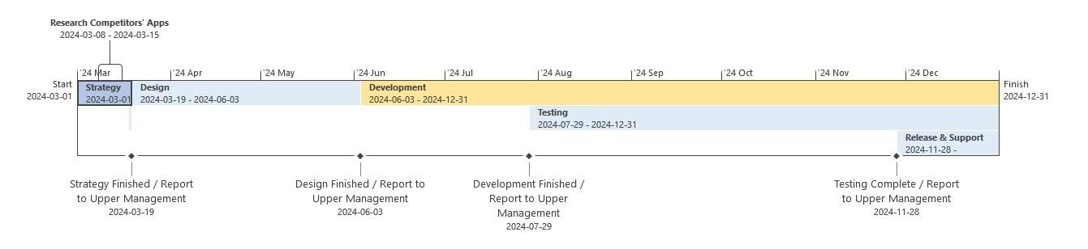

The timeline is laid out and so along with the resources table, cost tables, PERT/CPM chart, and WBS, the project plan for United Bank of Philadelphia's Android app is now complete.

**Android App System Requirements**

The next section of this document is for presenting the system requirements for the United Bank of Philadelphia Android app that has development in planning stages. To be covered are the requirements modeling, business process model, data flow diagram, data dictionary, object modeling, and use case diagrams for developing the new app.

# Requirements Model

## *Current System*

The current online banking system isn't a smartphone app but rather a website, as noted in (United Bank of Philadelphia, n.d. a). The website allows smartphone users to access it and log in to check their transactions and statements, but provides no transactions alerts, no online check deposit, no way of alerting the bank to upcoming travel, and also has no multi-factor or biometric authentication - instead opting for a simple username/password/recovery question system. The goal of the new Android app is to provide these missing features and more. The requirements listing is being modeled after the features listing in the author's previous document in this series, entitled *United Bank of Philadelphia: Project Plan* (Novasak, 2024a, p 2), as well as the features listing by Community Bank entitled *Mobile Banking: 10 Must-Have Features and Benefits* (Community Bank, 2022). These features are to be grouped into the following categories: outputs, inputs, processes, performance, and controls/security. Where the features fit will be based on the samples stated by Scott Tilley and Harry J. Rosenblatt in *Systems Analysis and Design* (11th ed.) (Tilley & Rosenblatt, 2016, pp 115/116).

## *Outputs*

The new app should have the following outputs:

* Transaction alerts sent as notifications to the customer's phone or tablet showing amount, date, time, business name, location, and available balance (Novasak, 2024);
* Ability for the customer to add their account to the digital wallet feature on their phone for contactless payment (Community Bank, 2022).

## *Inputs*

The inputs for the new app should be as follows:

* Allow the user to customize the user interface including text size and colors and show which type of information to present first upon log-in (available bank balance, last several transactions, check deposit, etc.) (Community Bank, 2022);
* Check deposit via phone or tablet camera scanning (Community Bank, 2022);
* Bill payment: let the user pay bills and loans via entering the payee name, their address, contact number, and account number for payment (Community Bank, 2022);
* Ability to set a budget based on time or dollar amounts and trigger an alert when the user is nearing their budgeted amount based on the time and/or dollar amount (Community Bank, 2022).

***Processes***

The processes of this new app will be as follows:

* Display of trends for money spent and received (Community Bank, 2022);
* Allow the user to categorize transactions (Community Bank, 2022);
* 1-tap access to customer service representatives by phone or online chat (Community Bank, 2022);
* Ability to transfer funds between accounts - could be done via dropdown box for same-user transfers (Community Bank, 2022).

***Performance***

Ensure the app is accessible 24/7, with any upcoming exceptions for maintenance alerted to users so they know of the downtime. Michael Hartland, of Snapcomms, an Everbridge company, recommends choosing a time of least impact to users for planned maintenance and sending a concise message to the users with the important details of which features or services will be unavailable, as well as the time and time zone this is to begin and end (Hartland, 2022).

***Controls/Security***

Security is essential to any banking app, and so these requirements will go a long way to ensuring users can have peace of mind in their finances are safe with the new Android app:

* Require Google Authenticator in addition to the username/password for logging into accounts every time the user wants to log into their bank account (Google Play, 2023);
* Allow the user to also set up fingerprint reading support for extra protection, if their device supports it (Isaid, 2023);
* Allow the user to temporarily freeze usage of their debit card if it is misplaced (Community Bank, 2022);
* Allow the user to specify a travel alert with start and end date and countries or states for their trip so the bank account will not be marked as fraud upon transactions in the destination based on the user's specified dates.

**Business Process Model**

Cflow, who has an article entitled *Effective Business Processes Mapping with Business Process Diagrams*, describes why it is essential to have a business process model. According to Cflow, a business process diagram helps reduce the complexity of a business's operations, and optimizes the precise sequence of tasks performed in the business (Cflow, 2023). Created the diagram involves a series of steps:

1. Identifying the primary tasks (Cflow, 2023);
2. Determine the order in which those tasks are to be done (Cflow, 2023);
3. Assign symbols to represent “decisions, inputs, outputs, start, and endpoints of the process” to help properly understanding the processes (Cflow, 2023);
4. Determine how the tasks are related (Cflow, 2023);
5. Ensure the start and end of processes is clearly marked (Cflow, 2023);
6. Review the diagram (Cflow, 2023).

**Figure B-1**

*Business Process Diagram. Adapted from (Visual Paradigm Online, n.d.).*

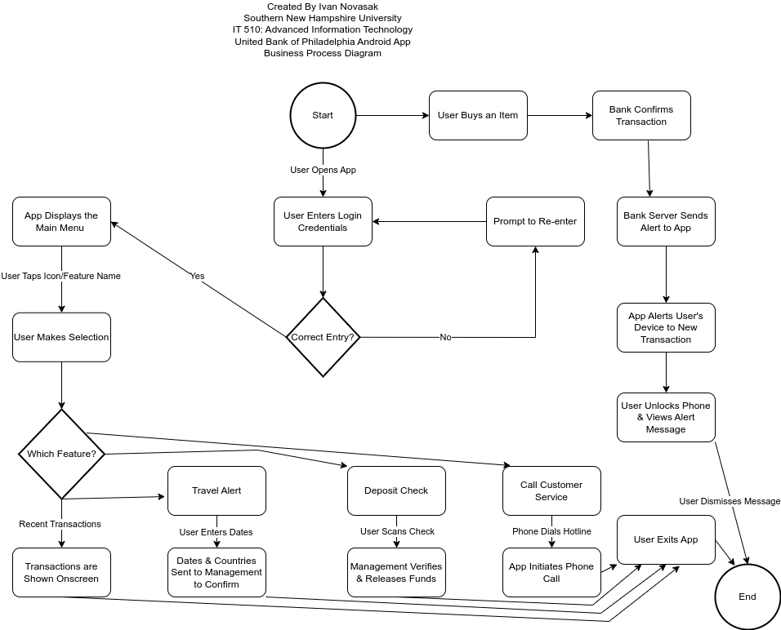

***Data Processes***

A data flow diagram shows where data flows between the app and bank systems. This is shown in 2 images in Figures B-2 and B-3. The Level 0 data flow diagram shows icons for the customer, manager, customer service representative, the bank, transactions listing, app feature display, the list of customers, and the list of employees (GeeksForGeeks, 2021). A closed rectangle is being used to represent the entities, a rectangle with open sides is being used to represent processes, the circle represents the banking system, and arrows represent what is happening between two events or feature activations (GeeksForGeeks, 2021). The Level 1 data flow diagram shows the equivalent processes, entities, and features using the app as the main reference point.

**Figure B-2**

*Data Flow Diagram - Level 0. Adapted from (GeeksForGeeks, 2021).*

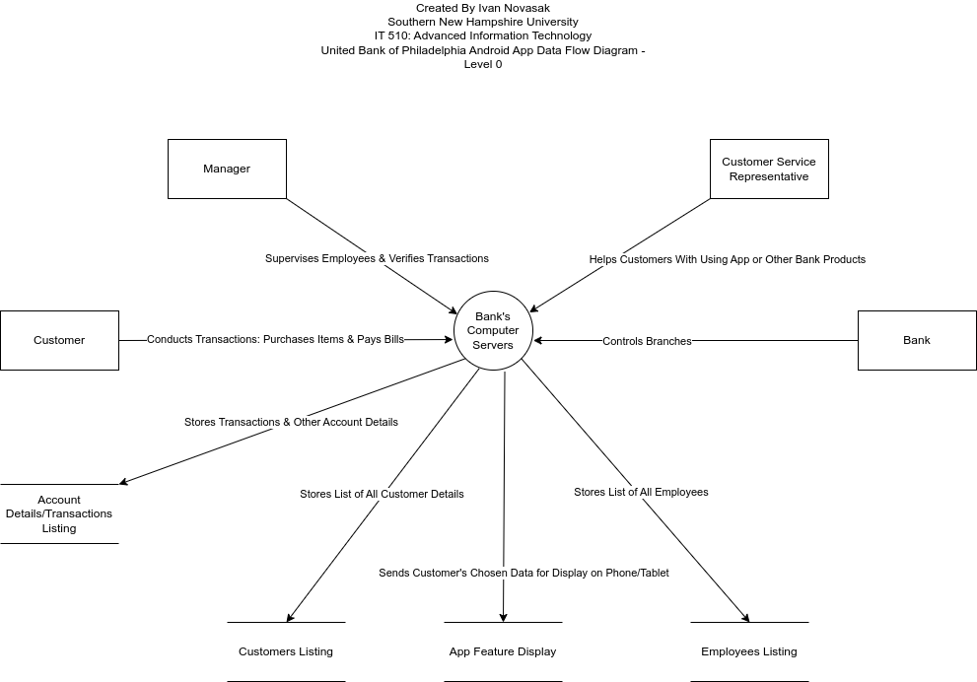

**Figure B-3**

*Data Flow Diagram - Level 1 - App Features. Adapted from (GeeksForGeeks, 2021).*

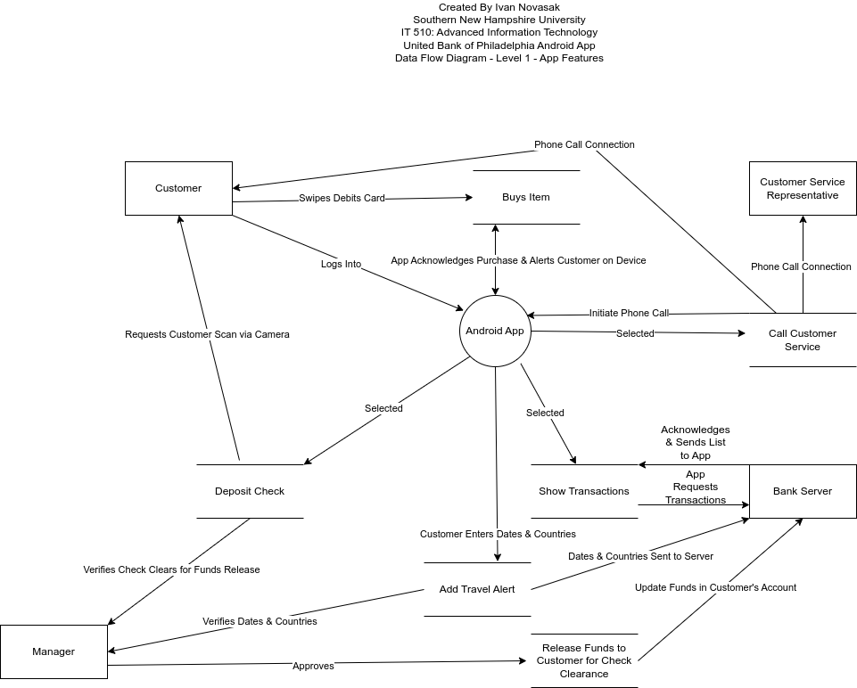

**Data Dictionary**

According to Scott Tilley and Harry J. Rosenblatt, a data dictionary, is a “central storehouse of information about the system's data” and “describes all data elements and meaningful combinations of data elements” (Tilley & Rosenblatt, 2016, p 160). Tilley and Rosenblatt also describe what data elements are, which are also called fields, as well as how these can be combined to form records (Tilley & Rosenblatt, 2016, p 160). Some examples of fields they state include, “student grade, salary, Social Security number, account balance, and company name”, and an example of a record they state for an automobile parts store has the data elements (fields), “part number, description, supplier code, minimum and maximum stock levels, cost, and list price”, in a record (Tilley & Rosenblatt, 2016, p 160). Some data dictionaries for the customer, their bank account, and the bill pay facility are shown in tables B-1 to B-4 inspired by the one presented by OSF Support in the article entitled *How to Make a Data Dictionary* (OSF Support, 2023). The columns represent the type of data element, and the rows represent the metadata about a specific variable and are adapted from (OSF Support, 2023).

**Table B-1**

*Data Dictionary for the Customer entity.*

|  |  |  |  |  |  |
| --- | --- | --- | --- | --- | --- |
| **Variable** | **Variable Name** | **Type** | **Domain** | **Description** | **Null Allowed** |
| Customer ID number | cid | Integer | 1–999999999 | Unique internal ID number for the customer | No |
| Customer's last name | cLastName | String | 255 Characters | Last name of the customer | No |
| Customer's first name | cFirstName | String | 255 Characters | First name of the customer | No |
| Customer's middle name(s) | cMiddleNames | String | 255 Characters | Middle names of customer (optional) | Yes |
| Customer's US Social Security number | cSSN | Char | Number with exactly 9 digits | US Social Security Number of the customer | Yes |
| Customer's government ID number | cGovtID | String | 128 Characters | Government ID number of the customer | No |
| Customer's government ID type | cGovtIDtype | String | 32 Characters | Type of Government ID | No |
| Customer's street address | cStreetAddr | String | 255 Characters | House number, direction, and street name of the customer's address | No |
| Customer's apartment number | cAptNum | String | 16 Characters | Customer's apartment number (optional) | Yes |
| Customer's city | cCity | String | 255 Characters | Customer's city | No |
| Customer's state/province | cState | Char | 2 Characters exactly | Customer's state/province (if available) | Yes |
| Customer's ZIP code/postal code | cZIP | String | 32 Characters | Customer's ZIP/postal code (if available) | Yes |
| Customer's country | cCountry | String | 255 Characters | Customer's country | No |
| Customer's phone number | cPhone | String | Number with up to 16 digits | Customer's phone number | No |
| Customer's phone type | cPhoneType | String | 16 Characters | Type of phone the customer has | No |
| Customer's email address | cEmail | String | 255 Characters | Email address of the customer | Yes |
| Type of customer | cCustType | String | 16 Characters | The type of customer: personal/business | No |

**Table B-2**

*Data Dictionary for the External Business entity.*

|  |  |  |  |  |  |
| --- | --- | --- | --- | --- | --- |
| **Variable** | **Variable Name** | **Type** | **Domain** | **Description** | **Null Allowed** |
| Business ID number | bid | Integer | 1–999999999 | Unique internal ID number for the business | No |
| Business name | bName | String | 255 Characters | Name of the business | No |
| Business payments account number | bPaymentAcctNum | String | 255 Characters | Account number for payments to this business | No |
| Business payments bank name | bPaymentBankName | String | 255 Characters | Name of the business's bank | No |
| Business's tax ID number | bTaxID | String | 128 Characters | Tax ID number for the business | No |
| Business's street address | bStreetAddr | String | 255 Characters | Street number, direction, and street name of the business's address | No |
| Business's PO Box number | bPObox | String | 16 Characters | PO Box number for the business (optional) | Yes |
| Business's city | bCity | String | 255 Characters | Business's city | No |
| Business's state/province | bState | Char | 2 Characters exactly | Business's state/province (if available) | Yes |
| Business's ZIP code/postal code | bZIP | String | 32 Characters | Business's ZIP/postal code (if available) | Yes |
| Business's country | bCountry | String | 255 Characters | Business's country | No |
| Business's phone number | bPhone | String | Number with up to 16 digits | Business's main phone number | No |
| Business's email address | bEmail | String | 255 Characters | Main email address of the business | No |

**Table B-3**

*Data Dictionary for the Bank Account entity.*

|  |  |  |  |  |  |
| --- | --- | --- | --- | --- | --- |
| **Variable** | **Variable Name** | **Type** | **Domain** | **Description** | **Null Allowed** |
| Account number | accountNum | Char | 12-digit number | The unique account number for this account | No |
| Is a Business Account | isBiz | Boolean | TRUE/FALSE | Boolean value: FALSE for Personal, TRUE for Business | No |
| Opened date | openedDate | DATE | 1992-01-01/2099-12-30 | Date the account was opened, in YYYY-MM-DD format | No |
| Closed date | closedDate | DATE | 1992-01-02/2099-12-31 | Date the account was closed, in YYYY-MM-DD format (if closed) | Yes |
| Current Balance | currBal | DOUBLE | -99999.99–999999999.99 | Amount of funds in the account that have posted (negative would mean overdrawn amount) | No |
| Available Balance | availBal | DOUBLE | -99999.99–999999999.99 | Amount of funds in the account that are available to spend now (negative would mean overdrawn amount) | No |
| Alerts status | receiveAlerts | Boolean | TRUE/FALSE | Whether or not this account has alerts enabled | No |
| Freeze status | isFrozen | Boolean | TRUE/FALSE | Whether or not this account is frozen | No |
| Linked customer | linkedCustomerID | Integer | 1–999999999 | Unique internal ID number for the customer or business linked to this account | No |
| Last used date | lastUseDate | DATE | 1992-01-01/2099-12-31 | Date the account was last used, in YYYY-MM-DD format | No |
| Last used time | lastUseTime | TIME | 00:00:00.000/23:59:59.999 | Time the account was last used, in 24-hour format | No |

**Table B-4**

*Data Dictionary for a Transaction entity.*

|  |  |  |  |  |  |
| --- | --- | --- | --- | --- | --- |
| **Variable** | **Variable Name** | **Type** | **Domain** | **Description** | **Null Allowed** |
| Transaction ID number | tID | Integer | 1–999999999999999999 | Unique ID number for the transaction | No |
| Transaction from account number | tFromAcctNum | Char | 12-digit number | The unique account number for the account funds are leaving | No |
| Transaction to account number | tToAcctNum | Char | 12-digit number | The unique account number for the account funds are going | No |
| Name of payee | payeeName | String | 255 Characters | The name of the person or business being paid | No |
| Transaction date | tDate | DATE | 1992-01-01/2099-12-31 | Date the transaction took place, in YYYY-MM-DD format | No |
| Transaction time | tTime | TIME | 00:00:00.000/23:59:59.999 | Time the transaction took place, in 24-hour format | No |
| Transaction amount | tAmount | DOUBLE | -999999.99–999999.99 | Amount of transaction | No |
| Business type for transaction | tType | String | 255 Characters | Type of business for this transaction | No |

The data dictionaries in Tables B-1 to B-4 show all the relevant metadata the app will need to display account data to the user. The next subject of discussion is the app's object model.

**Object Model**

Another way to analyze a product's development and components is called object-oriented analysis (Tilley & Rosenblatt, 2016, p 179). In this setup, objects represent “a real person, a place, an event, or a transaction” (Tilley & Rosenblatt, 2016, p 179). Objects have attributes, which are descriptive characteristics; as well as methods, which are the functions an object can do (Tilley & Rosenblatt, 2016, p 179). A diagram known as the Unified Modeling Language (UML) shows how objects and their functions are related to each other (Tilley & Rosenblatt, 2016, p 186). These UML diagrams are also known as class diagrams, because objects are also known as classes (Tilley & Rosenblatt, 2016, p 189). In a UML/class diagram, objects are represented as rectangles that are each split up into 3 smaller rectangles, with the top section being used for the object's name, the middle section being used for the object's attributes, and the bottom section being used for the object's methods (Tilley & Rosenblatt, 2016, p 180). Relationships between the objects are represented as lines that connect the large rectangles that represent objects (Tilley & Rosenblatt, 2016, p 189). Cardinalities, which are the number of instances of an object in the relationship, exist as zero or many, zero or one, one and only one, as well as one or many (Tilley & Rosenblatt, 2016, p 190). In the UML diagram, these respective cardinalities are represented as the symbols **0..**, **0..1**, **1**, and **1..\*** (Tilley & Rosenblatt, 2016, p 190). Figure B-2 shows a UML diagram showing the customer, account, transaction, external business, and app feature objects; as well as relationships between them for the planned United Bank of Philadelphia Android app. The cardinality symbols are placed at the ends of the lines near the objects.

**Figure B-2**

*UML Object Diagram, adapted from (CS Odessa, n.d.).*

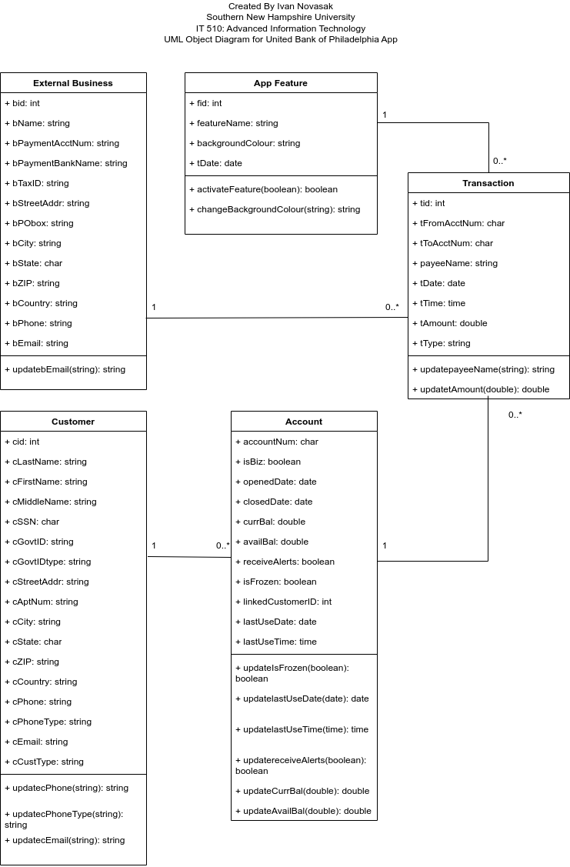

**Use Case Diagram**

According to Tilley and Rosenblatt, who said, “A use case represents the steps in a specific business function or process. An external entity, called an actor, initiates a use case by requesting the system to perform a function or process.” (Tilley & Rosenblatt, 2016, p 186). In Figure B-3, a use case diagram is presented showing off the sequence of how a customer may use some of the features in the app. In this use case diagram, the stick figures represent the involved parties, the rectangles represent the banks, the ovals represent uses of the app or events taking place in the app, and the arrows show the sequence of a given use or event to the next usage or event in the app.

**Figure B-3**

*Use Case Diagram. Adapted from (Tilley & Rosenblatt, 2016, p 189).*

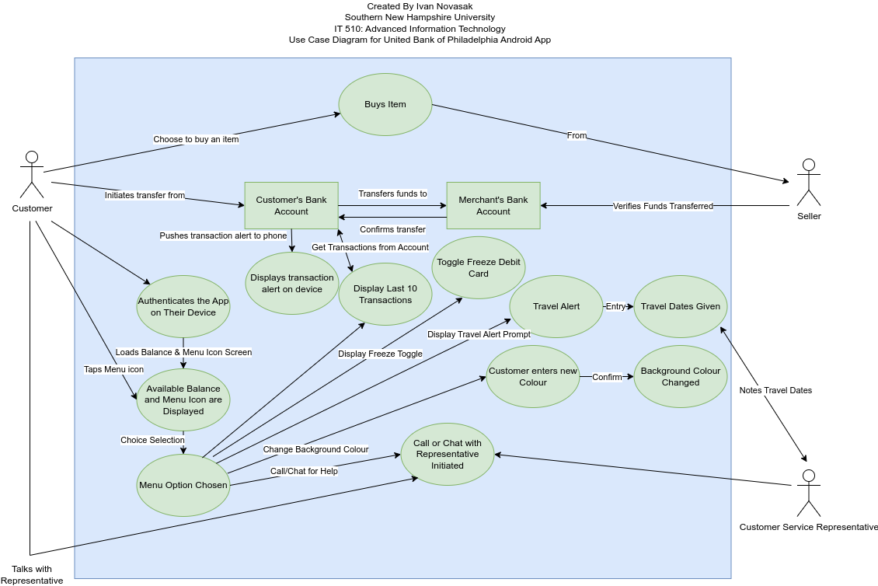

The diagrams shown in Figures B-1 to B-3 illustrate visually how the various functions in this banking app fit together and how a typical user may use the app. The data dictionary, shown in Tables B-1 to B-4, displays the kind of information the app will need to use and keep track of in order to function. The object model displays the entities, their attributes, and some methods for how features may be accessed via those entities. The next topic of discussion concerns the design of the system.

# Systems Design

This section is to lay out the systems design of the Android application for United Bank of Philadelphia. To be covered are the specifications of the system, data design, the user interface (UI), system architecture, and feasibility analysis of this app.

# Specifications

According to Dat Pham and Marek Alexa, of MeguMethod, the Jetpack Compose tool makes developing a user interface (UI) easier and twice as fast as coding it by hand, so this tool will be handy in developing the banking app (Pham & Alexa, 2023). Jetpack Compose requires an Android operating system (OS) version of at least 5.0 (Pham & Alexa, 2023). Pham and Alexa also state that Android OS versions are typically supported for an average of 3.3 years, after which security vulnerabilities may be discovered and left unfixed due to support ending (Pham & Alexa, 2023). These issues can be any of:

* Remote access to sensitive credentials, like passwords and bearer tokens (Pham & Alexa, 2023);
* Local access to those credentials (Pham & Alexa, 2023);
* “Bypassing operating system protections that reveal memory or file contents across app, user, or profile boundaries” (Pham & Alexa, 2023);
* Remote bypass of user interaction requirements, allowing access to data that requires authentication to access (Pham & Alexa, 2023).

With the security concerns in mind, Dat Pham and Marek Alexa recommend choosing to develop for a minimum Android OS version that is no more than 4 years old (Pham & Alexa, 2023). According to JR Raphael, of Computerworld, the current version of Android is 14, and the latest version that was in use 4 years ago was 10, which was released in September 2019 (Raphael, 2023). This will be the minimum version supported in the United Bank of Philadelphia app. The remainder of the app's specifications are discussed in (Novasak, 2024a/2024b) as well as the Data Design, User Interface Design, and Security sections in this document. Figure C-1 shows a diagram of the specifications of the Android app and its interaction with United Bank of Philadelphia. The symbols are being adapted from the Yourdon symbols listed in (Tilley & Rosenblatt, 2016, p 144). The specific symbols are light blue squares to represent the customer and customer service representative, light blue rectangles with the left and right sides open representing the bank accounts, and light blue circles representing specific features and processes the app and bank will do (Tilley & Rosenblatt, 2016, p 144). Another symbol, a purple cylinder, is being used to represent databases to avoid confusion with the bank accounts.

**Figure C-1**

*Specifications Diagram. Adapted from (Tilley & Rosenblatt, 2016, pp 144/155).*

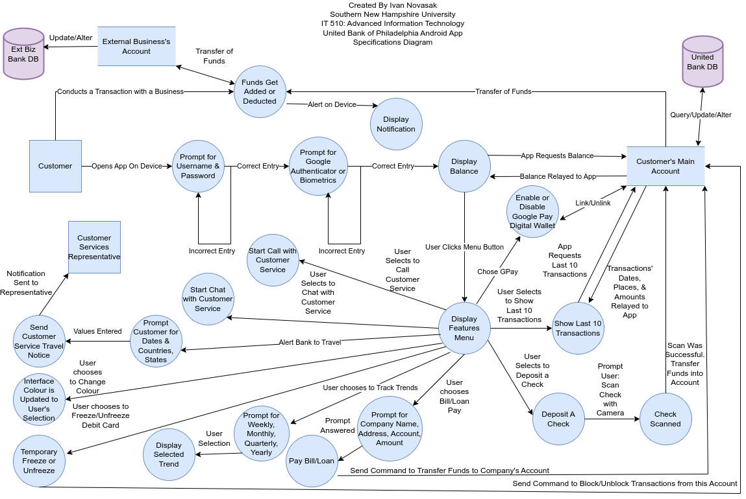

**Data Design**

The data design is based on the data dictionary shown in (Novasak, 2024b) with some modifications to ensure referential integrity and normal form (Tilley & Rosenblatt, 2016, pp 286, 297). Referential integrity ensures that any records that are linked across entities via a foreign key are linked to another entity's primary key (Tilley & Rosenblatt, 2016, p 286). Normal forms ensure that no attributes are repeated across different entities, and that instead such attributes are split off into their own database tables (Tilley & Rosenblatt, 2016, p 297). The data dictionary in (Novasak, 2024b) has separate attributes for address, phone number, and email contact data for both the customer and external business. The normalization process requires making a separate table to store such contact data like address, phone number, and email address into its own table. Similar work is done to avoid attribute duplication in the transaction entity table of business data.

***Entity Relationship Diagram***

The entity relationship diagram (ERD), shown in Figure C-2, displays the relevant entities, relationships, and cardinalities in Chen format. According to Patrycja Dybka, of Vertabelo SA, in Chen format the entities are represented as rectangles, attributes belonging to those entities are represented as ovals, relationships between those entities are represented as diamonds, and relationship cardinalities 1-to-1 (abbreviated as 1:1), 1-to-many (1:M), and many-to-many (M:N) are shown as the number 1 or letters M and N along the lines that link entities and relationships (Dybka, 2014). In this ERD, colored lines are being used to represent the relationships that cross over each other in the diagram as physical space was limited in the diagramming software (JGraph, n.d.).

**Figure C-2**

*Entity Relationship diagram for the United Bank of Philadelphia Android app. Adapted from (Dybka, 2014).*

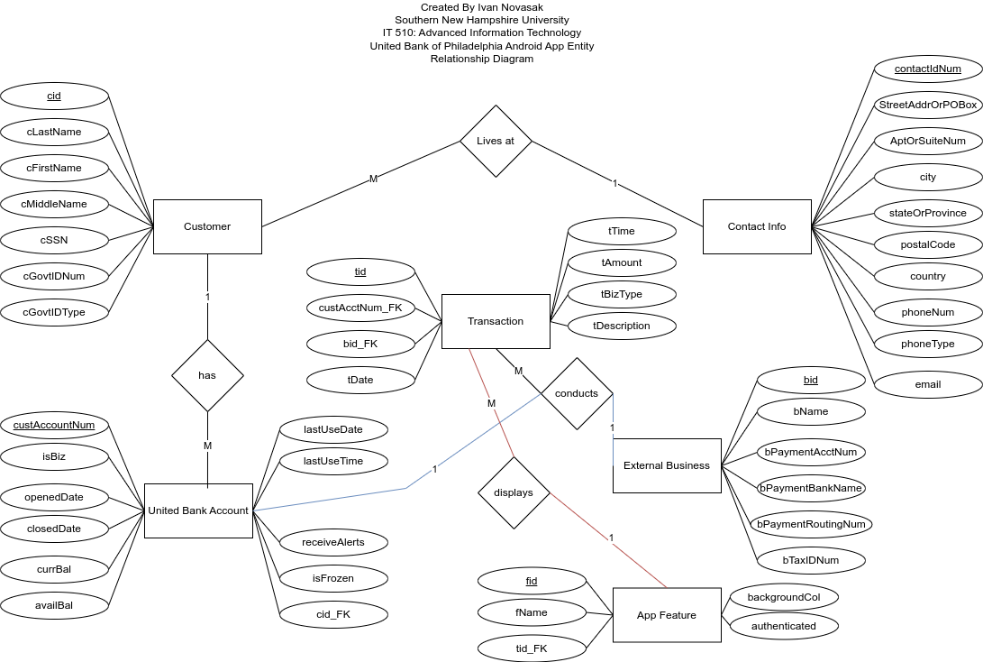

**User Interface Design**

The next area of requirements has to do with the user interface of the app. To be considered are both human-computer interactions (HCI) and the graphical user interface (GUI) itself, including sketches.

***Human Computer Interactions (HCI)***

According to Aurora Harley, of Nielsen Norman Group, for smartphone icons or other touch targets, the “minimum size should be 1cm × 1cm” to ensure that the user can tap the correct target with their finger or thumb (Harley, 2019). Another point she makes is to not put too many touch targets on the screen at once, and if using multiple touch targets, to space them out widely enough so that the user doesn't accidentally tap another touch target directly next to the intended one (Harley, 2019). A similar topic Harley mentions to take into account is something called view-tap asymmetry, which is “when elements are large enough to be seen (e.g., read the label text), but too small or densely packed to select without struggling” (Harley, 2019). One final point Harley mentions is to make sure the touch targets are larger for larger devices (like tablets) to ensure they will be noticeable (Harley, 2019).

***Graphical User Interface (GUI)***

According to user interface guidelines stated by Scott Tilley and Harry J. Rosenblatt in *Systems Analysis and Design*, a good UI does not call attention to it and instead is supposed to be made by focusing “on system design objectives”, as in what the user expects to do with the app (Tilley & Rosenblatt, 2016, p 241). They also say one should use a common design across the app, including the colors, “look and feel”, fonts, modules, and screen placements (Tilley & Rosenblatt, 2016, p 241). Having consistent behavior across the app's interface is important so the user clearly understands what the different icons and buttons do. Allowing the user to correct errors is important, as well (Tilley & Rosenblatt, 2016, p 241). There are some areas of the prototype United Bank app GUI that have text boxes that allow for easy typing and deletion inside them. The final point Tilley and Rosenblatt mention that is relevant to this app is, “Make it easy to navigate or return to any level in the menu structure.” (Tilley & Rosenblatt, 2016, p 241) Figures C-3 through C-13 show sketches of the various screens to be part of the app. Blue was chosen as the background color because it matches the blue color used on United Bank of Philadelphia's website as well as their debit cards (United Bank of Philadelphia, n.d. a). The large arrows between the screens represent the sequence between each screen. The smaller directional arrows in the menus as well as at the top of most of the screens indicate a forwards or reverse direction the user can go. Visme's website was used in the creation of the basic design of this GUI (Visme, n.d.). Modifications were made to add the extra menu options as well as the More Features menu. In sticking with the user guidelines set out by Tilley and Rosenblatt, as well as Aurora Harley, only the necessary number of icons and boxes were used to display what the user needs to see within the app (Tilley & Rosenblatt, 2016, pp 241/242; Harley, 2019). During the pilot testing of this app, suggestions will be allowed so any requested changes can be taken into account.

**Figure C-3**

*Sketch of the first screens that show when the user logs into the app.*

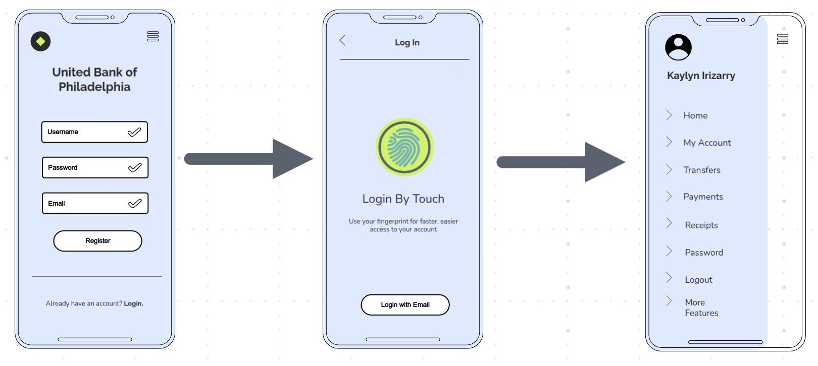

**Figure C-4**

*Sketch of the screen showing the user's account details.*

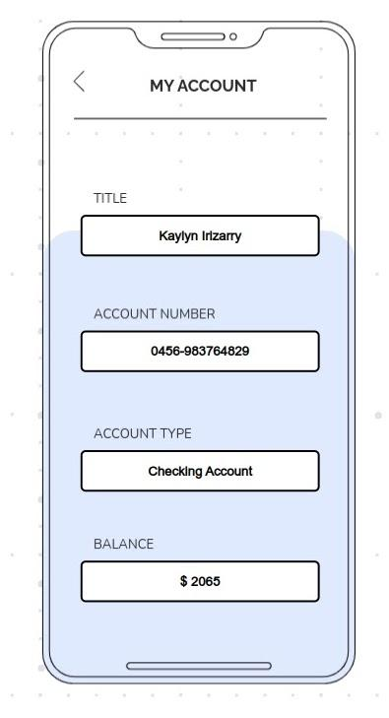

**Figure C-5**

*Sketch of the screen showing recent transactions and their types.*

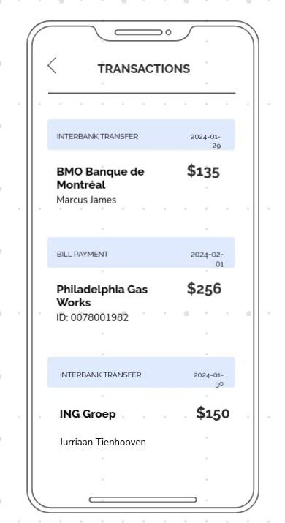

**Figure C-6**

*Sketch of the screen showing more features that the user can access.*

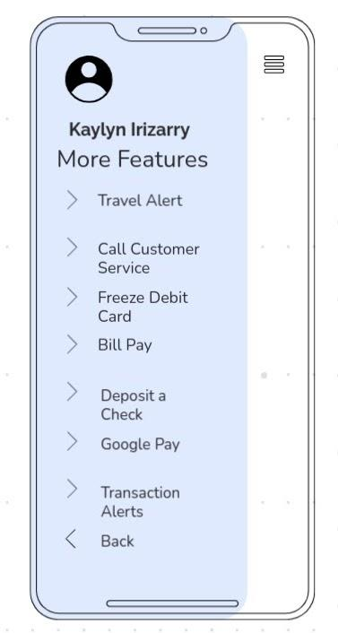

**Figure C-7**

*Sketch of the screen showing the user's travel alert setup.*

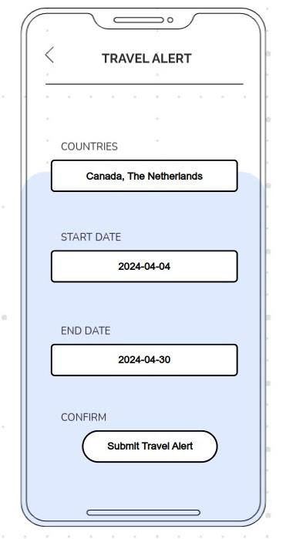

**Figure C-8**

*Sketches of the screen showing the user's debit card freeze status.*

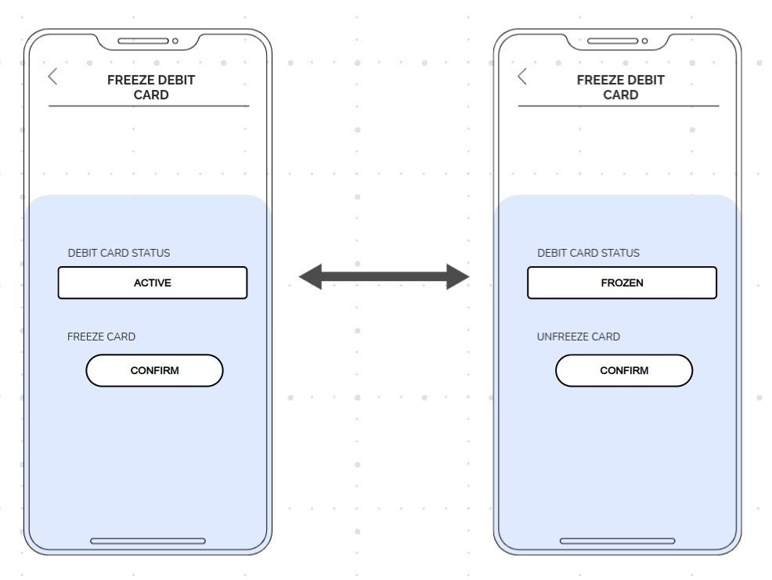

**Figure C-9**

*Sketch of the screen showing the user's bill pay information.*

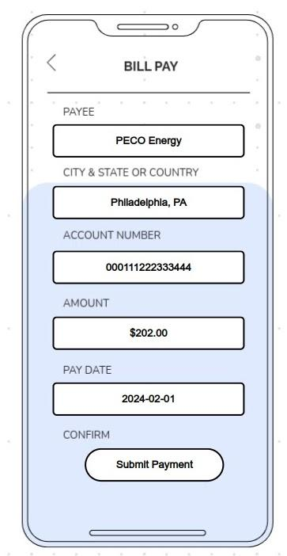

**Figure C-10**

*Sketch of the screen showing the check deposit dialogue.*

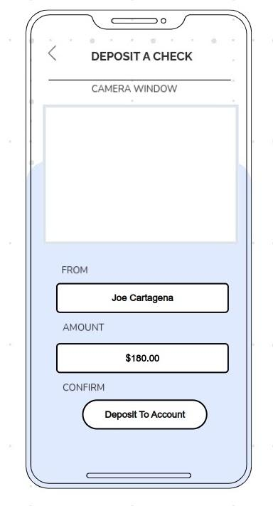

**Figure C-11**

*Sketches of the screen showing transaction activity alerts.*

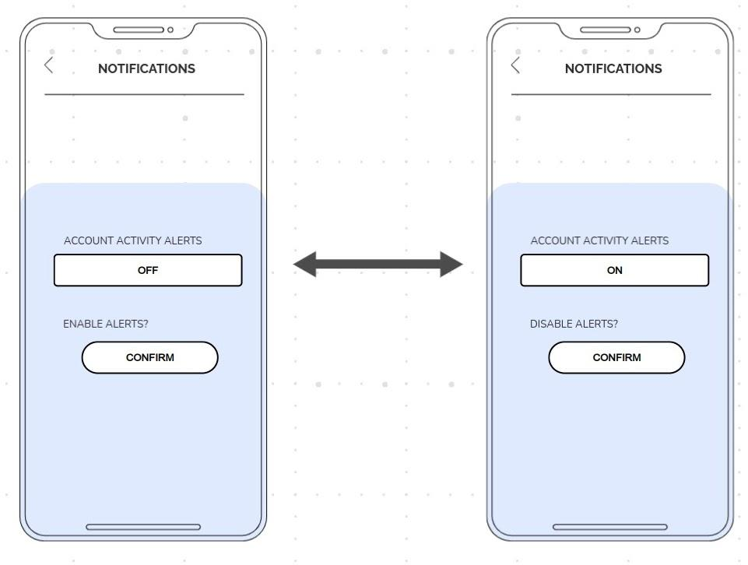

**Figure C-12**

*Sketch of a screen showing a sample transaction alert.*

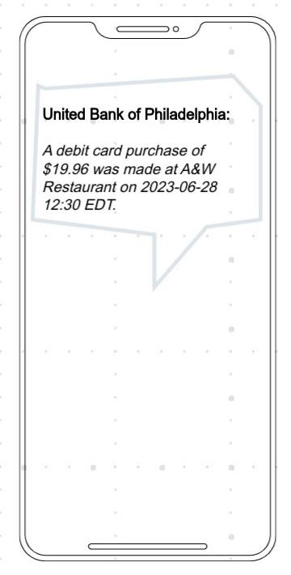

**Figure C-13**

*Sketch of the screen showing the background color change dialogue.*

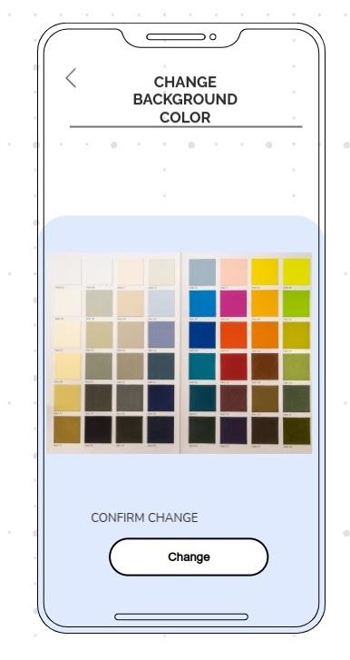

The user interface designs are complete. The next topic of discussion in this report is the system architecture.

**System Architecture**

In this section, the subjects to be discussed include corporate organization and culture, enterprise resource planning, total cost of ownership, scalability, web integration, legacy system interface requirements, processing options, and security.

***Corporate Organization and Culture***

According to the *About Us* page of United Bank of Philadelphia's website, their mission statement is “to deliver excellent customer service at a profit and to make United Bank of Philadelphia the ‘hometown’ bank of choice. Our goal is to foster community development by providing quality personalized comprehensive banking services to business (*sic*) and individuals in the Greater Philadelphia Region, with a special sensitivity to Blacks, Hispanics, Asians and women” (United Bank of Philadelphia, n.d. c).

The Board of Directors consists of:

* L. Armstead Edwards, who is Chairman of the Board and has been with United Bank of Philadelphia since March 1992 and one of the founding directors (United Bank of Philadelphia, n.d. c). He also is President and CEO of Edwards Entertainment Group (United Bank of Philadelphia, n.d. c).
* Rev. William B. Moore, who is Vice-Chairman of the Board of Directors and was a founding director (United Bank of Philadelphia, n.d. c). He also has been the Pastor of Tenth Memorial Baptist Church in Philadelphia since 1971, and at one time served as Deputy Director of the Philadelphia Parking Authority (United Bank of Philadelphia, n.d. c).
* Marionette Y. Wilson, who is Secretary of the Board of Directors and joined as a founding director in 1992 (United Bank of Philadelphia, n.d. c). She is retired but was “formerly the Co-Founder/Partner, John Frazier, Inc., Philadelphia, PA from 1981–2002” (United Bank of Philadelphia, n.d. c).
* Elwin P. Ross III, Esq., who is a Director, “is a founding member of the Legis Group LLC, a Pennsylvania Firm that provides legal counsel services to business clients” (United Bank of Philadelphia, n.d. c). He also used to be an “Associate in the Business & Finance Practice Group of Morgan, Lewis & Bockius LLP”, where he provided corporate advice to entrepreneurs on corporate structuring and venture financing (United Bank of Philadelphia, n.d. c).
* Evelyn Fennell Smalls, who is President and CEO and has been serving in that capacity since June 2000 (United Bank of Philadelphia, n.d. c). Prior, she “served as Partner and Consultant with the Community Development Services Group of Pennsylvania from 1984 through 1993” and also during “1973 through 1984, she was Vice President and Consultant to Executive Management at First Pennsylvania Bank of Philadelphia” (United Bank of Philadelphia, n.d. c).
* Bernard E. Anderson, who has been a Director since 2002 (United Bank of Philadelphia, n.d. c). He also “is a former Whitney E. Young, Jr., Professor of Management, The Wharton School, University of Pennsylvania, and a former economist at US Department of Labor” (United Bank of Philadelphia, n.d. c).

The Management Team consists of:

* Evelyn Fennell Smalls, President and CEO since June 2000, as mentioned in the Board of Directors section. She is “responsible for the leadership and management of the Bank including setting the direction of the organization, communicating its vision and adapting the culture and operations to achieve success” and has been in banking and community development since 1973 (United Bank of Philadelphia, n.d. c). In addition, Smalls “was appointed by the Federal Reserve Bank of Philadelphia and served a three-year term on the Community Depository Institutions Advisory Council (CDIAC)” (United Bank of Philadelphia, n.d. c).
* Brenda M. Hudson-Nelson has been serving as the Executive Vice President and Chief Financial Officer for over 25 years. Her roles include “directing financial planning, implementing, and overseeing the Bank's systems of internal controls, managing the Bank's investment portfolio, and monitoring and managing the Bank's sensitivity to interest rate risk”; ensuring “that the Bank's Annual Report, SEC Reports and other Regulatory Reports are filed accurately and timely”; as well as overseeing “the Bank's operations, including deposit operations and loan accounting” (United Bank of Philadelphia, n.d. c). Hudson-Nelson also “chairs the Bank's Technology Committee and is a member of the Bank's Officers’ Loan Committee, Officers’ ALCO Committee, Directors’ ALCO Committee, and Executive/Senior Management Committee” (United Bank of Philadelphia, n.d. c).
* Coston M. Cobbs has been SVP, Senior Lending Officer since January 2015 (United Bank of Philadelphia, n.d. c). Cobbs “is a seasoned commercial banker with over twenty five (*sic*) years of experience in commercial real estate lending” (United Bank of Philadelphia, n.d. c). The critical roles he serves in are strategic planning and “development and management of the commercial lending business and credit administration” (United Bank of Philadelphia, n.d. c).
* Dimitria Davenport is Vice President of Community Banking & Compliance for the last 18 years (United Bank of Philadelphia, n.d. c). Her roles include providing “leadership to the Community Banking team which includes oversight of the Bank's financial service centers and driving community development within the Bank's footprint” and “ensuring the Bank's adherence to all applicable consumer protection laws, and federal and state regulations” (United Bank of Philadelphia, n.d. c). She is also an advocate for education and uses her banking knowledge to teach financial literacy classes in Philadelphia (United Bank of Philadelphia, n.d. c). She “serves as a mentor to young adults and maintains an active affiliation with her community church, New Hope Temple Baptist Church where she has served for over 20 years” (United Bank of Philadelphia, n.d. c).

United Bank of Philadelphia has 2 branches: the main branch in Center City Philadelphia at 30 South 15th Street and another one at 1501 North Broad Street inside Progress Plaza near Temple University's main campus (United Bank of Philadelphia, n.d. b). Both locations are open Monday through Friday, opening at 9.00 a.m. and closing between 3.00 p.m. and 5.00 p.m. depending on the branch and weekday (United Bank of Philadelphia, n.d. b).

***Enterprise Resource Management and Total Cost of Ownership***

As the app in question is an Android app, the only mobile development software that will assist the development team in accomplishing the goal has to support Android. In the Specifications section of this document, one tool recommended by Dat Pham and Marek Alexa was Jetpack Compose which is for making Android app UIs. Igor Tomych, CEO of DashDevs and Fintech Garden, states that developers will need to be fluent in the Java and Kotlin programming languages, use the Android Studio, Android Developer Tools, and Android SDK (Tomych, 2023). Figure 5 in (Novasak, 2024a) is a Microsoft Project screenshot of a listing of the employees who will be hired to develop and maintain the Android app, as well as their pay rates. They are the product owner, business analyst, project manager, promotional representative, 2 junior app developers, 1 senior app developer, 3 customer service representatives, 2 quality assurance engineers, a UI designer, a back-end developer, and a talent recruiter (Novasak, 2024a). Microsoft Project is being used to keep track of the timeline for each phase of the project, as well as which roles will be needed for each task in the phases of app development.

Microsoft Project is also being used to track how much development will cost for the duration of the app's development, through the end of 2024. Figures 6–8 in (Novasak, 2024a) are Microsoft Project screenshots showing the phases and tasks of the development process as well as their costs. These costs are noted in Table C-1, which shows each development phase as well as its total cost, followed by the summation of all phases’ costs.

**Table C-1**

*Costs of developing the United Bank of Philadelphia app. Original values stated in (Novasak, 2024a).*

|  |  |
| --- | --- |
| **Development Phase** | **Cost** |
| 1. Strategy | $28,400.00 |
| 1. Design | $94,320.00 |
| 1. Development | $468,320.00 |
| 1. Testing | $358,720.00 |
| 1. Release & Support | $97,440.00 |
| (Sum of all phases) | $1,047,200.00 |

According to the *United Bancshares, Inc. 2014 Annual Report* (the most recent that is publicly available on United Bank of Philadelphia's website), during the 2009–2014 timeframe United Bank of Philadelphia's total assets ranged from $60.464 million to $77.017 million, and their noninterest expenses ranged from $4.416 million to $5.040 million (United Bank of Philadelphia, 2014, p 10). Keeping these amounts in mind, the development of the new app will cost between 20.8% and 23.7% (calculation: app development cost divided by noninterest expenses, multiplied by 100) more than the bank's typical noninterest expenses but only 1.4% to 1.7% (calculation: app development cost divided by total assets, multiplied by 100) of the bank's total assets.

***Processing Options***

The main decision is when and where online processing is more appropriate, as opposed to batch processing (Tilley & Rosenblatt, 2016, p 338). Operations that need to happen immediately without delay are best suited to using online processing, where activity can take place anytime and anywhere (Tilley & Rosenblatt, 2016, p 338). The features in this United Bank of Philadelphia app that come to mind that require online processing include logging into the account, displaying the available balance, notifying the user of a transaction that just happened, debit card freezing/unfreezing, background color change, scanning a check for depositing, setting a travel alert, and calling customer service. Batch processing is another way of processing data where a bunch of operations take place at one time of the day, week, or month (Tilley & Rosenblatt, 2016, p 338). The bank generating everyone's monthly statements on the last working day of the month, which show all transactions that took place that month, is one example of a batch operation. Some processes require both online and batch methods (Tilley & Rosenblatt, 2016, p 338). One such operation that may require a combination of batch and online processes is the process of depositing a check. The process begins online via the user using the app to scan the check, with the app sending the pictures to the bank's server, then later that day or the next working day staff at the bank will need to verify that all checks scanned that day are visible and legitimate before transferring funds into the corresponding accounts the next working day.

***Web Integration and Legacy Requirements***

The Android app being made is not an update to any previous app, so no legacy concerns exist as far as maintaining compatibility on devices that run Android OS versions below version 10. Two legacy concerns that may be of note involve the display of transaction data as well as whether or not to keep the original website's username and password system while only adding in the new Google Authenticator and biometric fingerprint features. Keeping the original username and passwords in place is more consumer-friendly, as they will be able to use their existing credentials to log into the Android app and will not require them to have 2 separate usernames and passwords for checking the same account. Middleware will need to be developed, if it doesn't already exist, that can communicate between the bank's existing IT systems and the new app (Tilley & Rosenblatt, 2016, p 332). The decision on whether any existing middleware for the website access is enough or if any new middleware will need to be bought or developed is left to the senior developer and the project manager, who will decide once development begins and the situation becomes clearer (Tilley & Rosenblatt, 2016, p 332).

***Security***

As a banking app, security of the user's funds and personal information is paramount. The reasons for restricting the operating system version are that this app will support versions 10 and up, which were discussed in the Specifications section of this document. Other layers of security that will be in force and are recommended by Igor Tomych are the username/password system, a new multi-factor authentication system using Google Authenticator and fingerprint biometrics, advanced encryption methods, and optional activity alerts for all transactions (Tomych, 2023). Vladimir Terekhov, CEO and co-founder of Attract Group (Terekhov, 2023), recommends some additional security layers which include:

* Regular security audits and regulatory compliance with financial industry standards (Terekhov, 2023);
* Secure session management, which includes automatic logout after a period of time of inactivity and secure cookie management (Terekhov, 2023);
* Fraud detection algorithms to quickly detect and alert users of possible fraud (Terekhov, 2023);
* API security, which protects the data between the app and bank's servers (Terekhov, 2023);
* Data obfuscation and tokenization, which “involves masking sensitive data and replacing it with unique identification symbols to retain all the essential information without compromising its security” (Terekhov, 2023).

Some of these security layers, notably tokenization, automatic logout, encryption, and data obfuscation, are already being used in United Bank of Philadelphia's existing website system, as noted on their *Identity Theft* webpage (United Bank of Philadelphia, n.d. d). These as well as the others mentioned in this section should be incorporated into the new Android app.

**Feasibility Analysis**

A3Logics, in their article entitled *What is Feasibility Analysis and How it is Important for Mobile App Development*, states that there are 4 types of feasibility that need to be analyzed and taken into consideration no matter what kind of app development project: market, technical, economic, and operational (A3Logics, 2023).

According to A3Logics, market feasibility is where the determination is made as to what kind of demand the new app will have, like who will be likely to use the app, the competition, and customers’ needs (A3Logics, 2023). Alexandra White, of CNBC, wrote in an article that was updated on 2 January 2024 entitled *Millennials and Gen Z are the most likely to use mobile banking apps—here's why, plus budgeting tips* that “99% of Gen Z and 98% of millennials use a mobile banking app for a wide range of tasks, including viewing account balances, checking their credit score and depositing a check. Gen X and Boomers use mobile banking apps less (86.5% and 69.5%, respectively), but the ones who do are still in the majority” (White, 2024). White also goes on to state “Most financial institutions, including banks and credit card issuers, now provide customers with user-friendly mobile apps for their smartphones. The Chase Mobile app, for instance, is available to Chase Sapphire℠ Banking account holders, as well as Chase Freedom Flex℠ cardholders” (White, 2024). With the given mobile banking app usage percentages of each of 4 different living generations in mind, it appears clear that a market exists for United Bank of Philadelphia to have a mobile app.

According to A3Logics, technical feasibility is the determination of whether an idea can physically be implemented (A3Logics, 2023). According to Elizabeth Gravier, of CNBC, in an article entitled *Best banks and credit unions for mobile banking of 2024*, “two out of three consumers can't live without their mobile banking apps” (Gravier, 2024). Gravier also states that Capital One, Discover, Chase, Bank of America, and Alliant Credit Union are amongst the best financial institutions with a mobile banking app (Gravier, 2024). In the article, she also mentions that all 5 of the mentioned banks’ apps support biometric security and have the following features common across all of the banking apps featured in the article: balance display, transaction history, money transfer, bill pay, freeze debit card, account alerts, and deposit checks (Gravier, 2024). So, the case has been made that several major banks already have mobile apps with many of the same features United Bank of Philadelphia intend to build, therefore it is technically feasible to build the app.

According to A3Logics, economic feasibility is where or not developing the app makes financial sense (revenues/profits increase) (A3Logics, 2023). In Alexandra White's 2024 CNBC article *Millennials and Gen Z are the most likely to use mobile banking apps—here's why, plus budgeting tips*, the percentages of bank customers that used a mobile banking app ranged from 69.5% to 99%, depending on the generational age brackets of customers (White, 2024). In the article, White also states that “54% of consumers agreed that they use digital banking tools more now, due to the pandemic” (White, 2024). Both statistics can form the assumption that both the demand for mobile banking will continue to rise and that not having it will be a liability as consumers can easily switch to a different bank that provides a mobile app. Ayana Jones, writing for The Philadelphia Tribune in 2017, quoted Dimitria Davenport, the vice president of Community Banking and Compliance at United Bank, “We saw a lot of young people who were not aware that United Bank existed, so for us it was a demographic shift. We are 25 years old, and our core depositors are older and so now we are starting to build relationships with the millennials” (Jones, 2017). Having a mobile app will go a long way to building that relationship with the millennial generation who heavily uses apps for their finances. Even if the only generation banking with United Bank were the boomers, of which 69.5% used banking apps (White, 2024), not having the app may cost up to 30.5% (100% - 69.5%) of those customers, which is like turning down revenue. So, it is economically feasible to build the app.

According to A3Logics, operational feasibility is whether an idea fits into the workflow of the business (A3Logics, 2023). It could include user management, maintenance, performance monitoring, customer support, security management, data management, or analytics (A3Logics, 2023). One of the requirements of the new app is easy access to call customer service, as stated in (Novasak, 2024a). Security concerns were addressed in the Specifications and System Architecture sections of this document. Alerting users by email and app notification of any upcoming maintenance would be a possible thing worth incorporating. Anastasiia Lastovetska, of MLSDev, presents 4 options for hiring new app developers: in-house, local boutique IT firm, freelancers, and outsourcing (Lastovetska, 2023). Security concerns and non-permanence possibility eliminate freelance and outsourcing, so that leaves considering the current IT staff and hiring locally from a boutique IT firm. Regarding staff, it is worth considering both assessing the current staff's software development skills as well as hiring a new team that specializes in mobile app development to develop this app. No information on the bank's web page showing their management staff indicates anyone specialized in mobile app development - only IT, which is a wide field with many different areas of specialization. Another possibility is hiring a mixture of internal and external local software developers. This could have the advantage of the internal developers being able to get the external developers used to the corporate culture at the bank.

Overall, the feasibility analysis determined that it is feasible to build the Android app for United Bank of Philadelphia. This concludes the Systems Design portion of the United Bank of Philadelphia Android app. This new Android app gives customers of United Bank of Philadelphia the same great functionality larger global banks have on-the-go from their smartphones and tablets. This will allow United Bank of Philadelphia to gain more customers in the millennial generation and generation Z demographics, who are entering age ranges where money management becomes more important.

# References

A3Logics. (2023, May 16). *What is Feasibility Analysis and How it is Important for Mobile App Development*. A3Logics. <https://www.a3logics.com/blog/what-is-feasibility-analysis-and-how-it-is-important-for-mobile-app-development>

All Business Schools. (2024, January 3). *Project Manager Salary Guide*. All Star Directories, Inc. <https://www.allbusinessschools.com/project-management/salary/>

Amigorena, F. (2019, December 2). *MFA and the Consequences for Companies Who Don't Use It*. CPO Magazine. <https://www.cpomagazine.com/cyber-security/mfa-and-the-consequences-for-companies-who-dont-use-it/>

Bennett, R. (2023, November 21). *7 key benefits of mobile banking*. Bankrate. <https://www.bankrate.com/banking/checking/benefits-of-mobile-banking/>

Bondar, J. (2023, September 28). *5 Essential stages of app development: From idea to release*. NIX United. <https://nix-united.com/blog/5-essential-stages-of-mobile-app-development/>

Cflow. (2023, October 11). *Effective Business Processes Mapping with Business Process Diagrams*. Cavintek, Inc. <https://www.cflowapps.com/business-process-diagram/>

Community Bank. (2022, July 14). *Mobile Banking: 10 Must-Have Features and Benefits.* Community Bank, N.A. <https://cbna.com/blog/personal-finance/mobile-banking-benefits>

Comparably. (n.d.). *Promotional Representative Salary*. Comparably. <https://www.comparably.com/salaries/salaries-for-promotional-representative>

CS Odessa. (n.d.). *Class UML Diagram for Bank Account System*. CS Odessa, Corp. <https://www.conceptdraw.com/examples/account-bank-uml>

Dybka, P. (2014, August 2). *Chen Notation*. Vertabelo SA. <https://vertabelo.com/blog/chen-erd-notation/>

GeeksforGeeks. (2021, March 5). *Data flow diagram for online banking system*. <https://www.geeksforgeeks.org/data-flow-diagram-for-online-banking-system/>

Glassdoor. (2024, January 4). *How much does a Customer Service Representative make in Philadelphia, PA?* Glassdoor LLC. <https://www.glassdoor.com/Salaries/philadelphia-customer-service-representative-salary-SRCH_IL.0,12_IM676_KO13,44.htm>

Google Play. (2023, May 24). *Google Authenticator*. Google LLC. <https://play.google.com/store/apps/details?id=com.google.android.apps.authenticator2&hl=en_GB>

Gravier, E. (2024, January 24). *Best banks and credit unions for mobile banking of 2024*. CNBC. <https://www.cnbc.com/select/best-banks-credit-unions-for-mobile-banking/>

Harley, A. (2019, May 5). *Touch targets on Touchscreens*. Nielsen Norman Group. <https://www.nngroup.com/articles/touch-target-size/>

Hartland, M. (2022, March 31). *How To Manage Scheduled Maintenance Messages (With Examples)*. SnapComms an Everbridge Company. <https://www.snapcomms.com/blog/scheduled-maintenance-messages>

Indeed. (n.d.). *Business analyst salary in Philadelphia, PA*. Indeed. <https://www.indeed.com/career/business-analyst/salaries/Philadelphia--PA>

Isaid. (2023, September 21). *Login with Biometrics on Android*. Android Developers. <https://developer.android.com/codelabs/biometric-login>

JGraph. (n.d.). *Draw.io*. JGraph Ltd. <https://www.drawio.com/>

Jones, A. (2017, October 24). *United Bank marks 25th anniversary*. The Philadelphia Tribune. <https://www.phillytrib.com/news/united-bank-marks-25th-anniversary/article_3752cb13-b691-5e87-bc5f-ea0b1063aa7a.html>

Lastovetska, A. (2023, June 15). *How to Hire an App Developer for Your Project.* MLSDev. <https://mlsdev.com/blog/hire-app-developer>

McMurrey, D. (n.d.) *Online Technical Writing: Audience analysis: Just who are these guys?* mcmassociates.io*.* <https://mcmassociates.io/textbook/aud.html>

Novasak, I. (2023, December 17). *Final Project Milestone 1: Business Case Proposal and Introduction*. Southern New Hampshire University.

Novasak, I. (2024a, January 7). *United Bank of Philadelphia: Project Plan*. Southern New Hampshire University.

Novasak, I. (2024b, January 21). *Milestone Three - United Bank of Philadelphia: Android App System Requirements.* Southern New Hampshire University.

Organ, C., & Bottorff, C. (2023, June 14). *Work Breakdown Structure (WBS) in Project management*. Forbes Media LLC. <https://www.forbes.com/advisor/in/business/what-is-work-breakdown-structure/>

OSF Support. (2023, May 5). *How to Make a Data Dictionary*. Center for Open Science. <https://help.osf.io/article/217-how-to-make-a-data-dictionary>

Pham, D., & Alexa, M. (2023, March 15). *Recommended minimum SDK version for Android projects*. MeguMethod s.r.o. <https://www.megumethod.com/blog/recommended-minimum-sdk-version-for-android-projects>

Raphael, J.R. (2023, October 20). *Android versions: A living history from 1.0 to 14*. Computerworld. <https://www.computerworld.com/article/3235946/android-versions-a-living-history-from-1-0-to-today.html?page=2>

Salary.com. (n.d.). *Agile Product Owner salary in Philadelphia, Pennsylvania*. Salary.com. <https://www.salary.com/research/salary/listing/agile-product-owner-salary/philadelphia-pa>

Sanghvi, R. (2023, September 29). *Android App Development cost: factors, estimates, and budgeting*. BitCot, Inc. <https://www.bitcot.com/android-app-development-cost/>

Terekhov, V. (2023, November 15). *Guide to Mobile Banking App Development: Key Features, Security, and Cost Insights*. Attract Group. <https://attractgroup.com/blog/guide-to-mobile-banking-app-development/>

Tilley, S., & Rosenblatt, H. J. (2016). *Systems Analysis and Design* (11th ed.). Cengage Limited. <https://mbsdirect.vitalsource.com/books/9781337424202>

Tomych, I. (2023, October 25). *How To Create A Mobile Banking App?* Dashdevs. <https://dashdevs.com/blog/how-to-create-a-mobile-banking-app/>

United Bank of Philadelphia. (2014). *United Bancshares, Inc. 2014 Annual Report*. United Bank of Philadelphia. <https://www.ubphila.com/ContentDocumentHandler.ashx?documentId=49611>

United Bank of Philadelphia. (n.d. a). *Home page*. United Bank of Philadelphia. <https://www.ubphila.com/>

United Bank of Philadelphia. (n.d. b). *Find a Branch or ATM*. United Bank of Philadelphia. <https://www.ubphila.com/Branch-ATM-Locations.aspx>

United Bank of Philadelphia. (n.d. c) *About Us*. United Bank of Philadelphia. <https://www.ubphila.com/About-Us.aspx>

United Bank of Philadelphia. (n.d. d). *Identity Theft*. United Bank of Philadelphia. <https://www.ubphila.com/Identity-Theft.aspx>

Visme. (n.d.). *Banking Mobile App wireframe template*. Easy WebContent, Inc. (DBA Visme). <https://www.visme.co/templates/wireframes/banking-mobile-app-wireframe-templates-1425289351/>

Visual Paradigm Online. *Banking process flowchart*. Visual Paradigm. <https://online.visual-paradigm.com/diagrams/templates/flowchart/banking-process-flowchart/>

White, A. (2023, July 12). *Millennials and Gen Z are the most likely to use mobile banking apps—here’s why, plus budgeting tips*. CNBC. <https://www.cnbc.com/select/why-millennials-gen-z-use-mobile-banking-apps/>

ZipRecruiter. (n.d.). *Talent Acquisition Recruiter Salary*. ZipRecruiter, Inc. <https://www.ziprecruiter.com/Salaries/Talent-Acquisition-Recruiter-Salary>